# CIS5200 Term Project Tutorialhttps://avatars2.githubusercontent.com/u/4156894?v=3&s=100

# 

**Authors: Taimoor Khan, Eddie Castanon, Shuvadeep Kundu, Ankita Paul**

#### **Instructor: [Jongwook Woo](https://www.linkedin.com/in/jongwook-woo-7081a85)**

#### **Date: 05/17/2020**

**Lab Tutorial**

Taimoor Khan ( [tkhan9@calstatela.edu](mailto:tkhan9@calstatela.edu) )

Eddie Castanon ( [ecastan@calstatela.edu](mailto:ecastan@calstatela.edu) )

Shuvadeep Kundu ( [skundu@calstatela.edu](mailto:skundu@calstatela.edu) )

Ankita Paul ( [apaul11@calstatela.edu](mailto:apaul11@calstatela.edu) )

05/17/2020

**Iowa Liquor Sales Analysis Using HiveQL in Oracle Cloud: BDCE**

**Objectives**

In this hands-on lab, we will manipulate and analyze CSV files in HDFS using HiveQL in Oracle Cloud Big Data Compute Edition (BDCE). We will use BDCE Hive query that analyzes the liquor sales data to get insight into how the sales have increased over the year, what have been the top selling categories of liquor, which counties and cities have ranked highest in sales in terms of volumes and revenues and we will also analyze the sales trend of a particular category of liquor over a year across the counties, doing a tempo-spatial analysis. We will learn how to:

* Download the data files and put them into HDFS
* Create Hive tables to query those data
* Create Hive queries to analyze the data
* Store the output results in table for data extraction
* Use Microsoft Excel to connect to BDCE Hadoop (using an ODBC connection) to retrieve the analyzed data
* Create Visualization on Excel 3D Map and Power BI

[ **Note:** It is highly recommended to copy the codes to **Notepad** or **Notepad++** before pasting them on the shell environment. This is to check errors due to changes in indentations while copying from the doc/pdf file.]

**Platform Specifications**

* **Cluster version** : Hadoop 2.7.1.2.4.2.0-258
* **Cluster size** : 1003.6 GB
* **Cluster Number of Nodes**: 3 (1 Master Node & 2 Slave Nodes)
* **Number of Processors**: 32
* **Memory** : 241.821 GB
* **CPU Speed** : 2.20GHz
* **Hive version**: Apache Hive version 1.2.1000.2.4.2.0-258
* **Microsoft Excel 2013** installed

**Step 1: Connect to Oracle Cloud BDCE using SSH**

We have used the ip address provided by the Instructor. Our CalStateLA username is username/pwd for Oracle account to SSH to the server at BDCE.

ssh [apaul11@129.150.71.75](mailto:apaul11@129.150.71.75)

**Step 2 : Download the data files from Amazon S3**

Once we remotely access our BDCE using ssh, we can download the two data files **iowa_Liquor_Sales.csv** and **Cleaned_location_data.csv** from Amazon S3 as follows:

$ wget -O iowa_Liquor_Sales.csv https://projectcis5200.s3-us-west-1.amazonaws.com/iowa_Liquor_Sales.csv

Here is how it looks like:

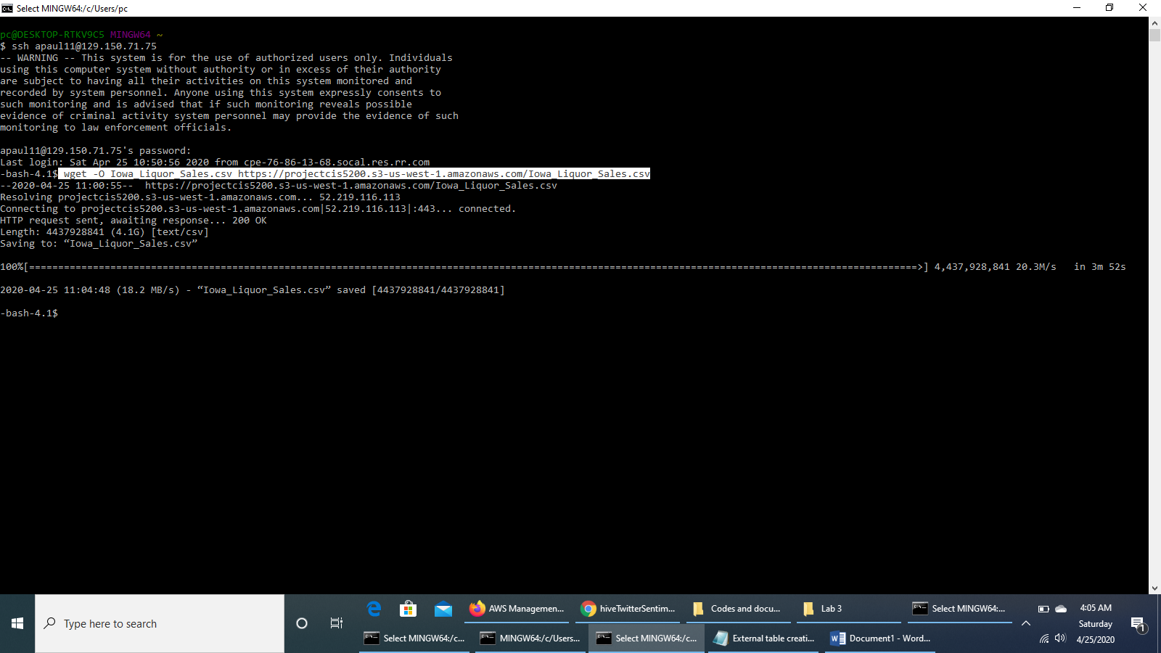

$ wget –O Cleaned_location_data.csv https://projectcis5200.s3-us-west-1.amazonaws.com/Cleaned_location_data.csv

**Step 3 : Upload the iowa_Liquor_Sales.csv file and Cleaned_location_data.csv file to HDFS**

We upload “iowa_Liquor_Sales.csv” file to ***projectfolder*** directory of HDFS:

$ hdfs dfs -mkdir projectfolder

$ hdfs dfs -ls

$ hdfs dfs -put Iowa_Liquor_Sales.csv projectfolder/

$ hdfs dfs -ls projectfolder/

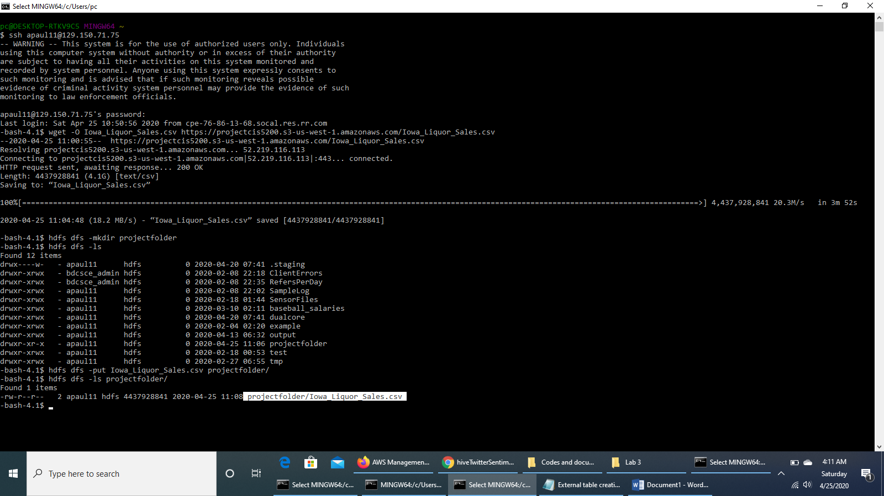

We create another folder ***tempo_spatial_data*** in the *projectfolder* and put the *Cleaned_location_data.csv* file in it.

$ hdfs dfs -mkdir projectfolder/tempo_spatial_data

$ hdfs dfs -put Cleaned_location_data.csv projectfolder/tempo_spatial_data/

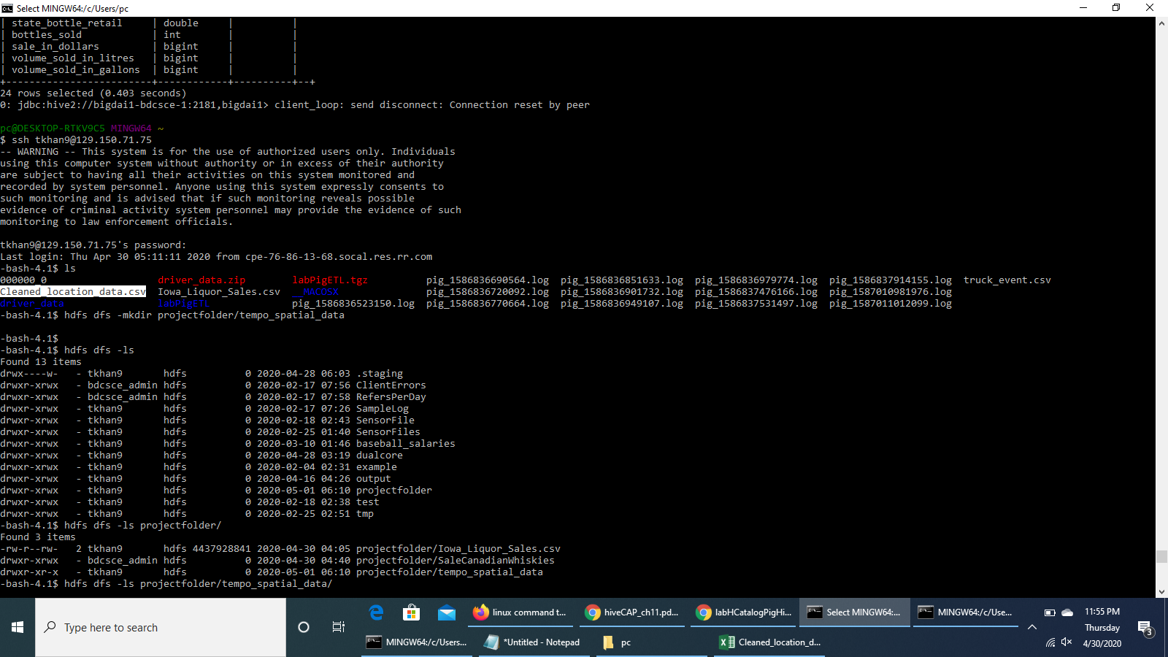

**Step 4 : Run the HDFS command, open beeline CLI and copy and paste “!connect …” command**

Run the following command to make beeline command work.

$ hdfs dfs -chmod -R o+w .

Open hive shell environment using beeline as follows:

$ beeline

Then copy and paste the connect command as follows:

beeline> !connect jdbc:hive2://bigdai1-bdcsce-1:2181,bigdai1-bdcsce-2:2181,bigdai1-bdcsce-3:2181/;serviceDiscoveryMode=zooKeeper;zooKeeperNamespace=hiveserver2?tez.queue.name=interactive bdcsce_admin

We have to hit the enter key to move to the next prompt.

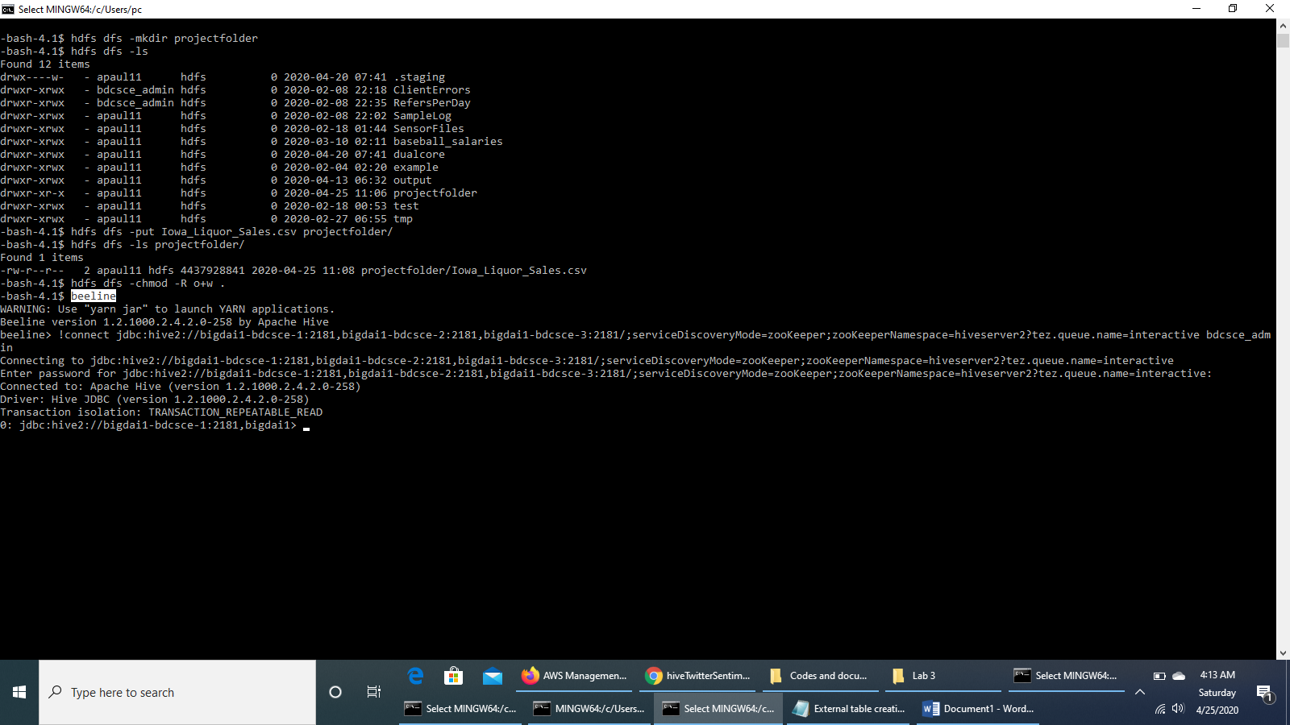

**Step 5 : See the list of databases already created and use our database to run further queries**

0: jdbc:hive2://bigdai1-bdcsce-1:2181,bigdai1> show databases;

0: jdbc:hive2://bigdai1-bdcsce-1:2181,bigdai1> use apaul11;

[**Note:** Alternatively: use tkhan9;]

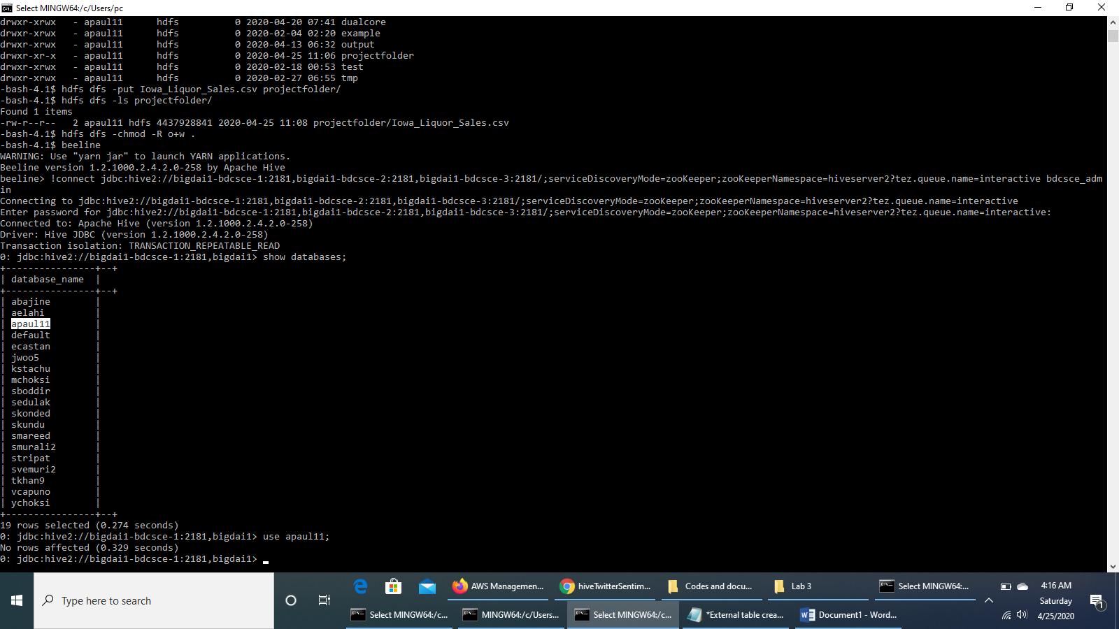

**Step 6 : Run the HiveQL code to create an external table named *iowaliquorsales***

The following Hive statement creates an external table that allows Hive to query data stored. External tables preserve the data “*iowa_Liquor_Sales.csv*” in the original file format, while allowing Hive to perform queries against the data within the file.

The Hive statement below creates a new table, named **iowaliquorsales**, by describing the fields within the files, the delimiter between fields, and the location of the file.

DROP TABLE IF EXISTS iowaliquorsales;

CREATE EXTERNAL TABLE IF NOT EXISTS iowaliquorsales(Invoice_Item_Number string, Sale_Date

date, Store_Number string, Store_Name string, Address string,

City string, Zip_Code string, Store_Location string, County_Number

string, County string,

Category string, Category_Name string, Vendor_Number string, Vendor_Name

string, Item_Number string,

Item_Description string, Pack int, Bottle_Volume_ml int, State_Bottle_Cost

double, State_Bottle_Retail double, Bottles_Sold int, Sale_in_Dollars double,

Volume_Sold_in_Litres double, Volume_Sold_in_Gallons double )

ROW FORMAT DELIMITED FIELDS TERMINATED BY ','

STORED AS TEXTFILE LOCATION '/user/tkhan9/projectfolder/'

TBLPROPERTIES ('skip.header.line.count'='1');

In the Hive shell, check that the table *iowaliquorsales* has been created.

0: jdbc:hive2://bigdai1-bdcsce-1:2181,bigdai1> show tables;

We can check the detailed structure of the table *iowaliquorsales*.

0: jdbc:hive2://bigdai1-bdcsce-1:2181,bigdai1> describe iowaliquorsales;

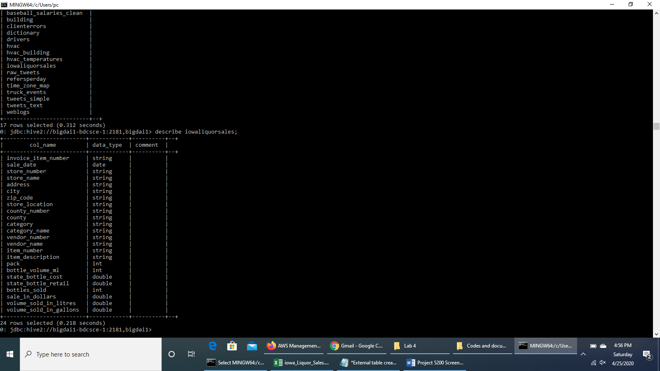

**Step 7 : Check if the table *iowaliquorsales* has the value once it is well created**

We can query the content of the table by executing the following HiveQL code:

SELECT * FROM iowaliquorsales LIMIT 2;

It will show results like this:

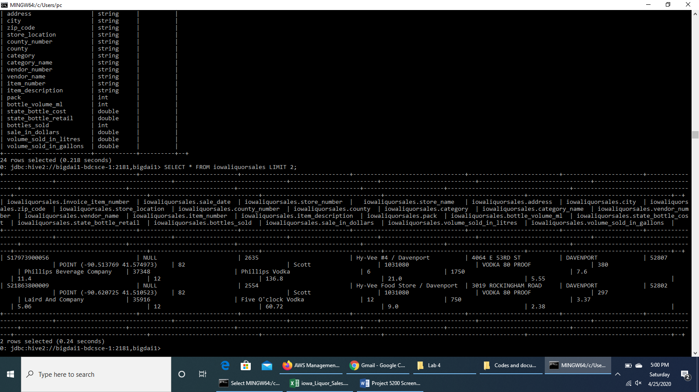

We will alter the data types of the column **sale_date** from *date* to *timestamp*, **sale_in_dollars**, **volume_sold_in_litres** and **volume_sold_in_gallons** from *double* to *bigInt*. We will also change the date format.

ALTER TABLE iowaliquorsales CHANGE sale_date sale_date timestamp;

ALTER TABLE iowaliquorsales CHANGE sale_in_dollars sale_in_dollars bigint;

ALTER TABLE iowaliquorsales CHANGE volume_sold_in_litres volume_sold_in_litres bigint;

ALTER TABLE iowaliquorsales CHANGE volume_sold_in_gallons volume_sold_in_gallons bigint;

ALTER TABLE iowaliquorsales SET SERDEPROPERTIES ("timestamp.formats"="MM/dd/yyyy");

**Step 8 : Creating Hive Queries to Analyze Data**

The following Hive queries run the different analysis we want to conduct from the available data stored in the external table ***iowaliquorsales***.

**To analyze Sales trend of liquor over the years**

This query will give the output of the total sales of liquor in terms of dollar over the years from 2012 to 2019.

SELECT sum(sale_in_dollars) sales ,

YEAR(sale_date) year

from iowaliquorsales

Where YEAR(sale_date) <> "2020"

GROUP BY YEAR(sale_date)

ORDER BY year;

It will display result something like follows:

+------------+-------+--+

| sales | year |

+------------+-------+--+

| 198524922 | 2012 |

| 201545077 | 2013 |

| 205225955 | 2014 |

| 211075281 | 2015 |

| 239263649 | 2016 |

| 286802051 | 2017 |

| 306403425 | 2018 |

| 323272184 | 2019 |

+------------+-------+--+

**The Top 10 counties in terms of sale amount in Dollars**

This query will order the counties in descending order in terms of the total sales amount in dollars and display the top 10 ranked counties in terms of sales amount.

SELECT sum(sale_in_dollars) sales ,

upper(County) County

from iowaliquorsales

GROUP BY upper(county)

ORDER BY sales desc limit 10;

This will display the result something like this:

+------------+-------------+--+

| sales | County |

+------------+-------------+--+

| 467166579 | POLK |

| 173088633 | LINN |

| 150261318 | SCOTT |

| 128496823 | JOHNSON |

| 117662679 | BLACK HAWK |

| 65079282 | STORY |

| 64078347 | WOODBURY |

| 55271223 | DUBUQUE |

| 43276988 | DALLAS |

| 39991152 | POTTAWATTA |

+------------+-------------+--+

**The Top 5 categories of liquors sold with highest volume in Litres**

The following Hive query will group the categories of liquors in terms of total sales volumes and order them from highest to lowest accordingly. It will display the names of the top 5 categories of liquors sold with the category of liquor having the highest sales volumes in total, all over the years. It will also display the sales amount generated by those categories.

SELECT SUM(Volume_Sold_in_Litres) volume,

SUM(sale_in_dollars) sales ,

upper(Category_Name) CategoryName

FROM iowaliquorsales

GROUP BY upper(Category_Name)

ORDER BY volume DESC limit 5;

This will display the result something like this:

+-----------+------------+-----------------------------------+--+

| volume | sales | category |

+-----------+------------+-----------------------------------+--+

| 74956842 | 219044703 | CANADIAN WHISKIES |

| 37087643 | 74699762 | WHISKEY LIQUEUR |

| 30385401 | 45535241 | IMPORTED VODKA |

| 25229906 | 15606657 | PUERTO RICO & VIRGIN ISLANDS RUM |

| 20750759 | 130601226 | VODKA 80 PROOF |

+-----------+------------+-----------------------------------+--+

**The Top 10 cities with highest sales in Dollars**

The following Hive query will group the cities of Iowa in terms of the total sales amount over the years and order them from highest to lowest rank in terms of their total sales amount. The top 10 cities will be displayed as the output.

SELECT sum(sale_in_dollars) sales ,

upper(City) City

FROM iowaliquorsales

GROUP BY upper(City)

ORDER BY sales DESC LIMIT 10;

This will display the result something like this:

+------------+------------------+--+

| sales | city |

+------------+------------------+--+

| 251444500 | DES MOINES |

| 132398171 | CEDAR RAPIDS |

| 105224873 | DAVENPORT |

| 82323488 | WEST DES MOINES |

| 74015353 | IOWA CITY |

| 72986564 | WATERLOO |

| 71404175 | COUNCIL BLUFFS |

| 61493084 | SIOUX CITY |

| 59293361 | AMES |

| 51061449 | DUBUQUE |

+------------+------------------+--+

**Sale of Canadian Whiskies across counties for the year 2019**

The following query will return the sale records of each date in 2019 for the liquor category ***Canadian Whiskies*** along with their Invoice/Item numbers and the name of the counties where they were sold.

SELECT Invoice_Item_Number,

sale_in_dollars sales,

County,

sale_date

FROM iowaliquorsales

where upper(category_name) = 'CANADIAN WHISKIES'

And YEAR(sale_date) = "2019";

The result will be displayed as follows:

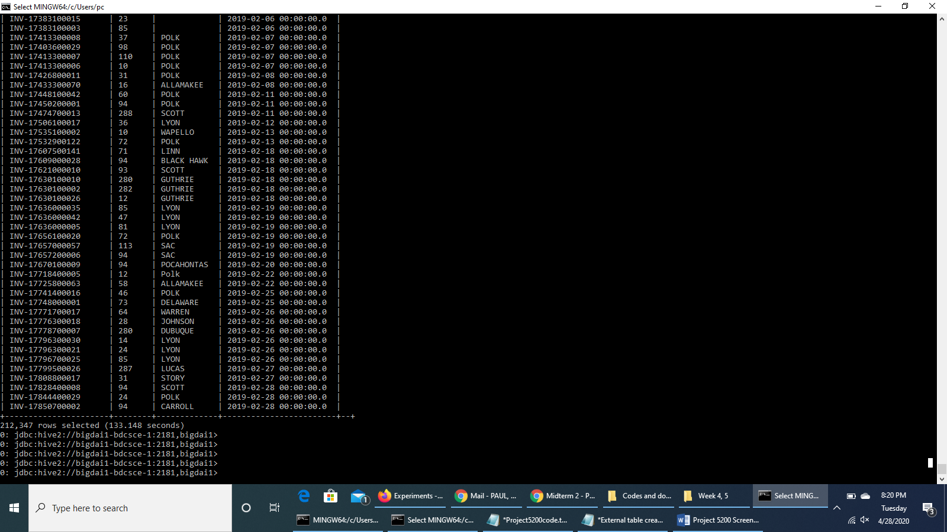

**Step 9 : Create a Hive table to store the output for data extraction**

We have to store the output data in a table before we can extract it to our local computer. The following HiveQL code will create a table ***SaleCanadianWhiskies*** to store the data of the sale of *Canadian Whiskies* across counties for the year 2019 for extraction.

DROP TABLE IF EXISTS SaleCanadianWhiskies;

CREATE TABLE IF NOT EXISTS SaleCanadianWhiskies

ROW FORMAT DELIMITED FIELDS TERMINATED BY ','

STORED AS TEXTFILE LOCATION '/user/tkhan9/projectfolder/SaleCanadianWhiskies/'

AS

SELECT Invoice_Item_Number,

sale_in_dollars sales,

County,

sale_date

FROM iowaliquorsales

where upper(category_name) = 'CANADIAN WHISKIES'

And YEAR(sale_date) = "2019";

Press **CTRL+Z** to exit Beeline.

At the local linux terminal, run the following HDFS command to check the path of the output file:

hdfs dfs -ls projectfolder/SaleCanadianWhiskies

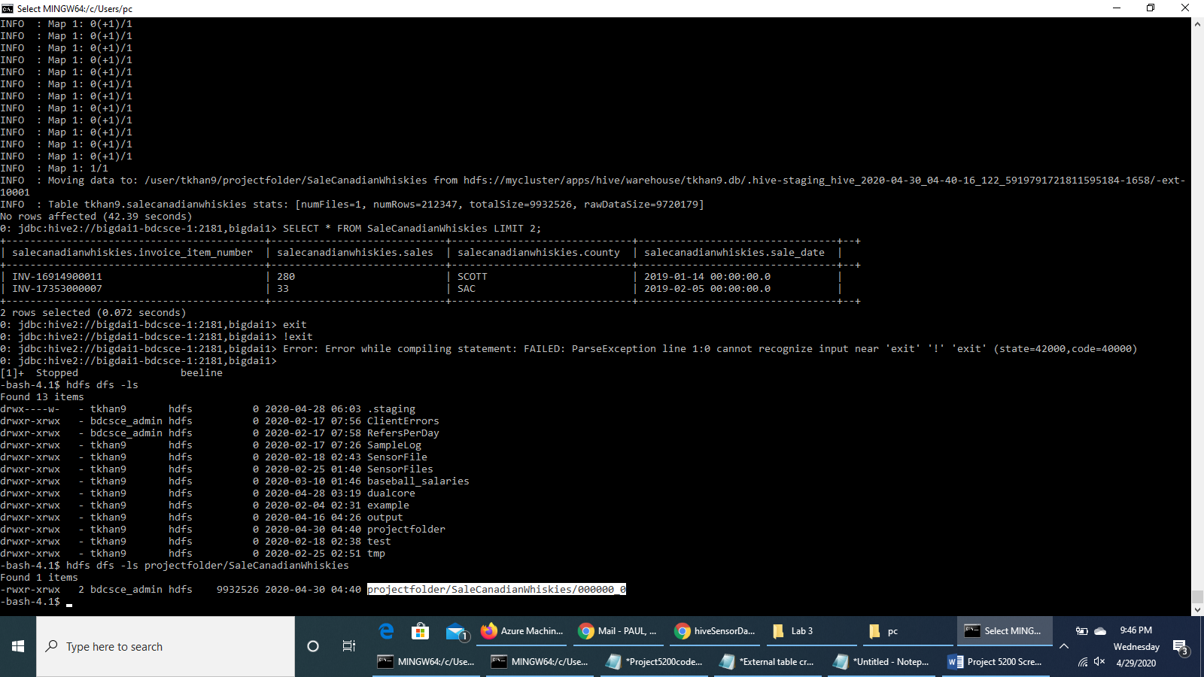

It will list **000000_0** file.

**Step 10 : Data extraction to local computer**

After the Hive tables are created, we can download the result to our local PC using Git Bash as follows:

1. Download the output file to the local file systems using the command:

hdfs dfs -get projectfolder/SaleCanadianWhiskies/000000_0

Check that the **000000_0** file has been downloaded, i.e, whether it appears in the list of items in the linux terminal.

ls –al

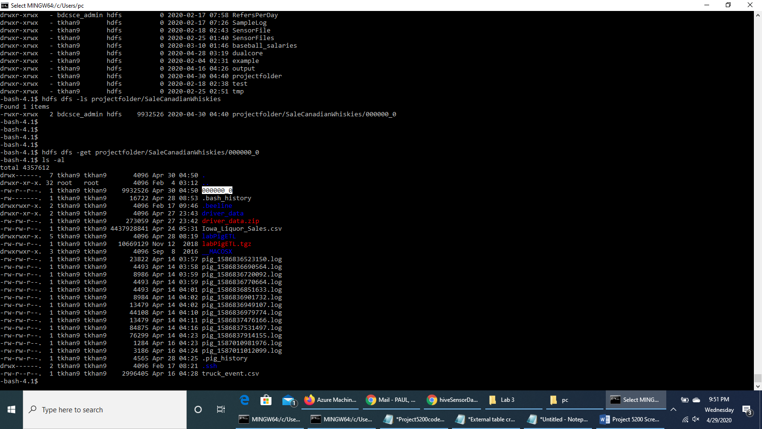

2. Open another terminal with git bash terminal in order to read/import the output file using our lab computer (or our PC/Laptop) - ww have to download the file to our computer (or our PC/Laptop).

scp tkhan9@129.150.71.75:/home/tkhan9/000000_0 000000_0.csv

3. Go to the search box of our lab computer (or PC/laptop), type **000000_0.csv** and you will find the output file in your computer.

**Screenshot of the extracted csv file:**

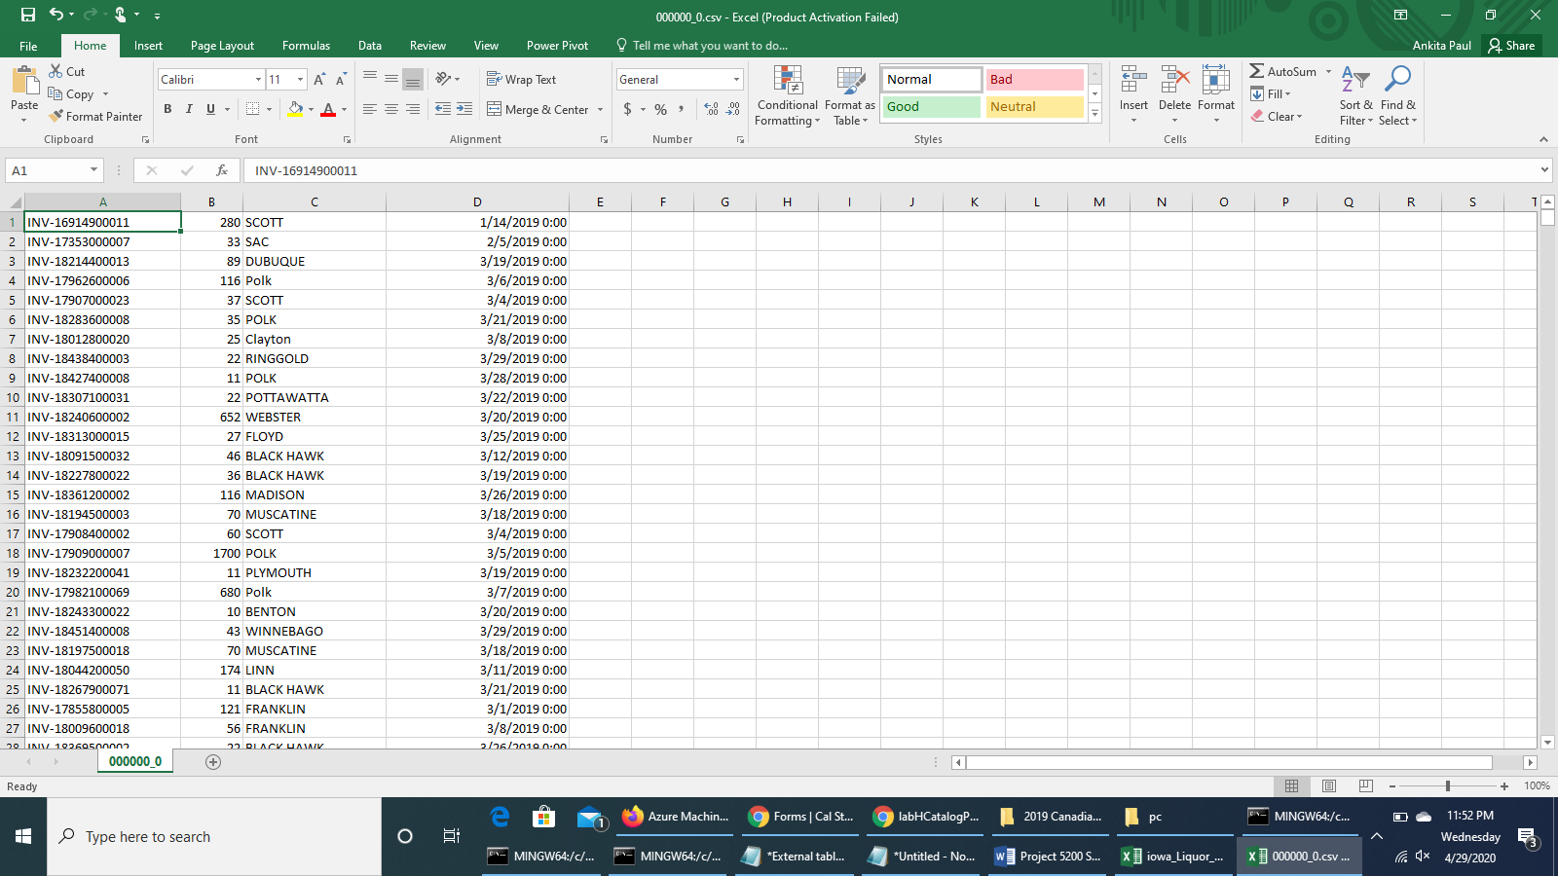

**Tempo-spatial analysis - Sale of Canadian Whiskies across counties**

We would use the cleaned dataset “***Cleaned_Location_data.csv***” that we had downloaded from Amazon S3 and uploaded to ***tempo_spatial_data*** directory in projectfolder for this part. We had cleaned the data by splitting the “Store Location” column from the orginal dataset into two separate columns of “Longitude” and “Latitude”.

Before proceeding with the next part of analysis, we will remove the previous output data file.

$ rm 000000_0

Run the earlier commands to connect to Beeline and use the database tkhan9 by running the Hive command in Beeline CLI.

$ hdfs dfs -chmod -R o+w .

$ beeline

Copy and paste the connect command as follows:

beeline> !connect jdbc:hive2://bigdai1-bdcsce-1:2181,bigdai1-bdcsce-2:2181,bigdai1-bdcsce-3:2181/;serviceDiscoveryMode=zooKeeper;zooKeeperNamespace=hiveserver2?tez.queue.name=interactive bdcsce_admin

Hit the enter key to move to the next prompt.

0: jdbc:hive2://bigdai1-bdcsce-1:2181,bigdai1> show databases;

0: jdbc:hive2://bigdai1-bdcsce-1:2181,bigdai1> use tkhan9;

**Create an external table *sale_location_data***

We will create an external table **sale_location_data** to preserve the data “*Cleaned_Location_data.csv*” in the original file format, while allowing Hive to perform queries against the data within the file.

DROP TABLE IF EXISTS sale_location_data;

CREATE EXTERNAL TABLE IF NOT EXISTS sale_location_data(Invoice_or_Item_Number string, Date_of_sale date, StoreNumber string, StoreName string, City string, Zip_Code string, Longitude double, Latitude double, County string, Category_Name string, Sale_Amount double, Volume_Sold_litres double)

ROW FORMAT DELIMITED FIELDS TERMINATED BY ','

STORED AS TEXTFILE LOCATION '/user/tkhan9/projectfolder/tempo_spatial_data/'

TBLPROPERTIES ('skip.header.line.count'='1');

Check that the table *sale_location_data* has been created.

0: jdbc:hive2://bigdai1-bdcsce-1:2181,bigdai1> show tables;

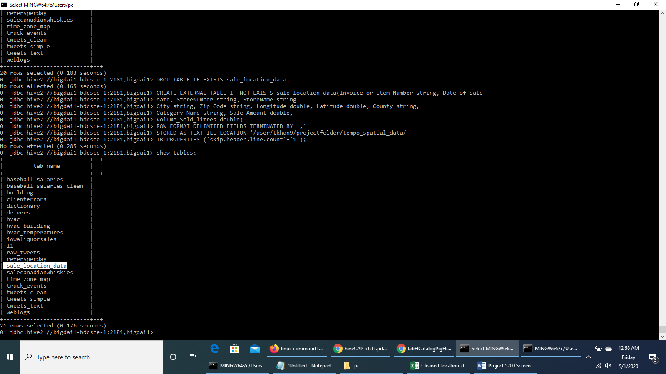

We will alter the columns data types of the **Date_of_sale** from *date* to *timestamp*, **Sale_Amount**, and **Volume_Sold_litres** from *double* to *bigInt*. We will also change the date format.

ALTER TABLE sale_location_data CHANGE Date_of_sale Date_of_sale timestamp;

ALTER TABLE sale_location_data CHANGE Sale_Amount Sale_Amount bigint;

ALTER TABLE sale_location_data CHANGE Volume_Sold_litres Volume_Sold_litres bigint;

ALTER TABLE sale_location_data SET SERDEPROPERTIES ("timestamp.formats"="MM/dd/yyyy");

We will check the detailed structure of the table *sale_location_data* using the ***describe*** command.

DESCRIBE sale_location_data;

Check if the table *sale_location_data* has the value once it is well created.

SELECT * FROM sale_location_data LIMIT 2;

The result will display something like this:

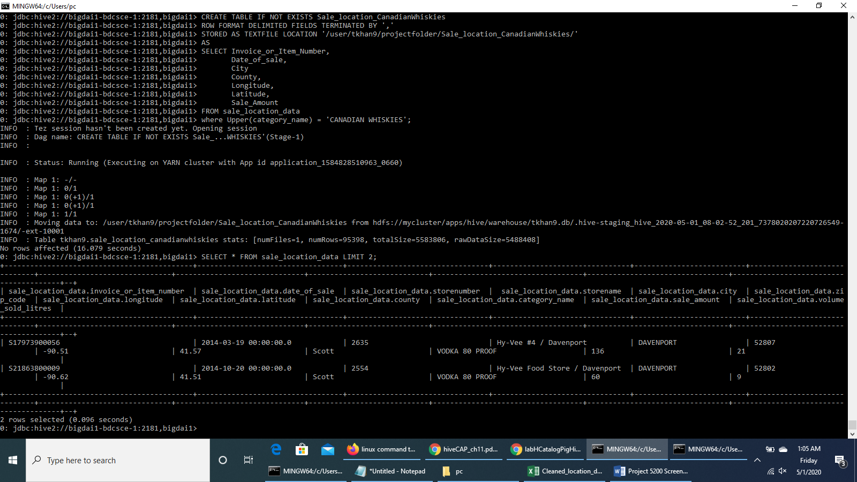

**We run HiveQL code to create a table *Sale_location_CanadianWhiskies* to store the data of the sale of Canadian Whiskies across counties over the years**

We have to store the output data in a table before we can extract it to our local computer. The following HiveQL code will create a table ***Sale_location_CanadianWhiskies*** to store the data of the sale of *Canadian Whiskies* across counties over the years, for extraction.

DROP TABLE IF EXISTS Sale_location_CanadianWhiskies;

CREATE TABLE IF NOT EXISTS Sale_location_CanadianWhiskies

ROW FORMAT DELIMITED FIELDS TERMINATED BY ','

STORED AS TEXTFILE LOCATION '/user/tkhan9/projectfolder/Sale_location_CanadianWhiskies/'

AS

SELECT Invoice_or_Item_Number,

Date_of_sale,

County,

Longitude,

Latitude,

Sale_Amount

FROM sale_location_data

where Upper(category_name) = 'CANADIAN WHISKIES';

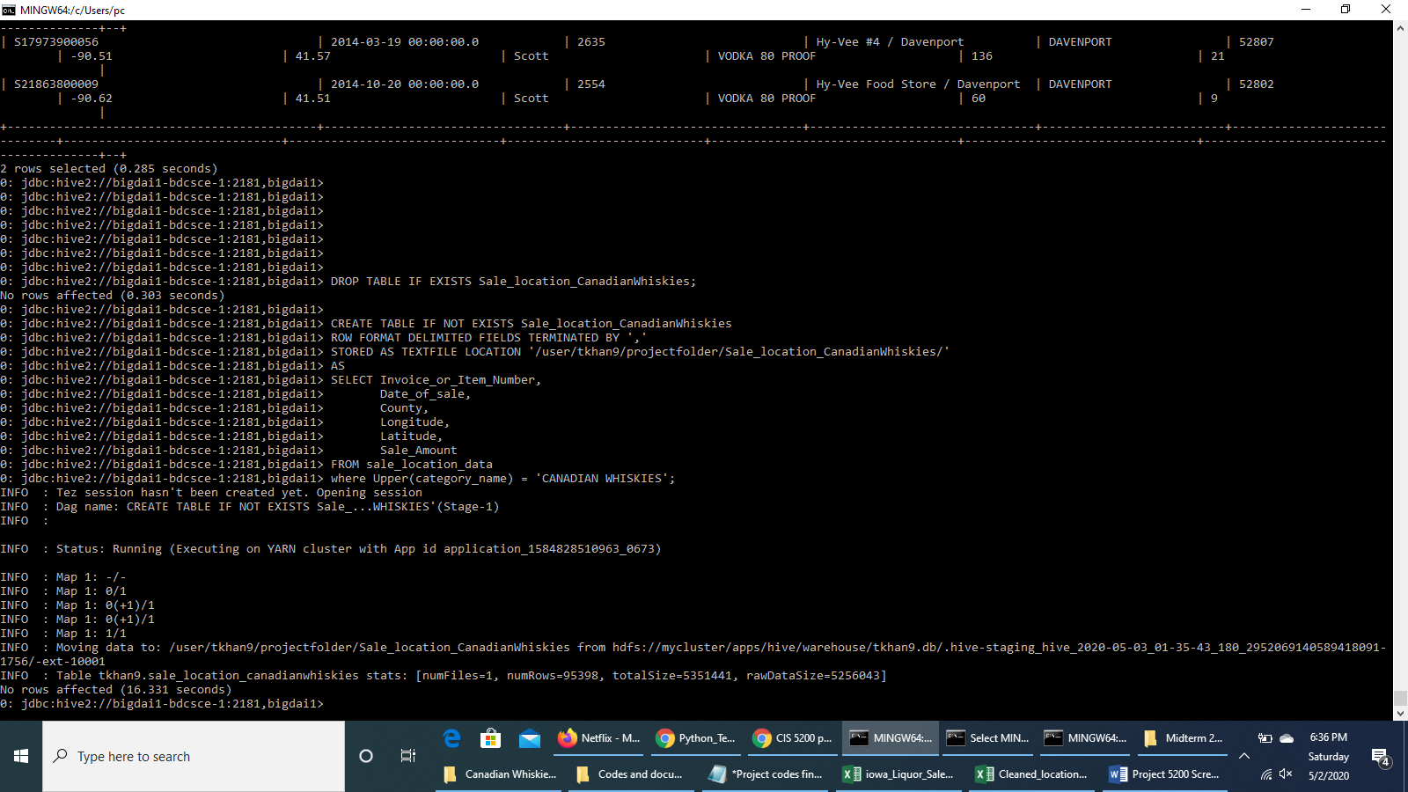

We run a query to see the resulting data upto 2 rows.

SELECT * FROM Sale_location_CanadianWhiskies LIMIT 2;

It will display result something like this:

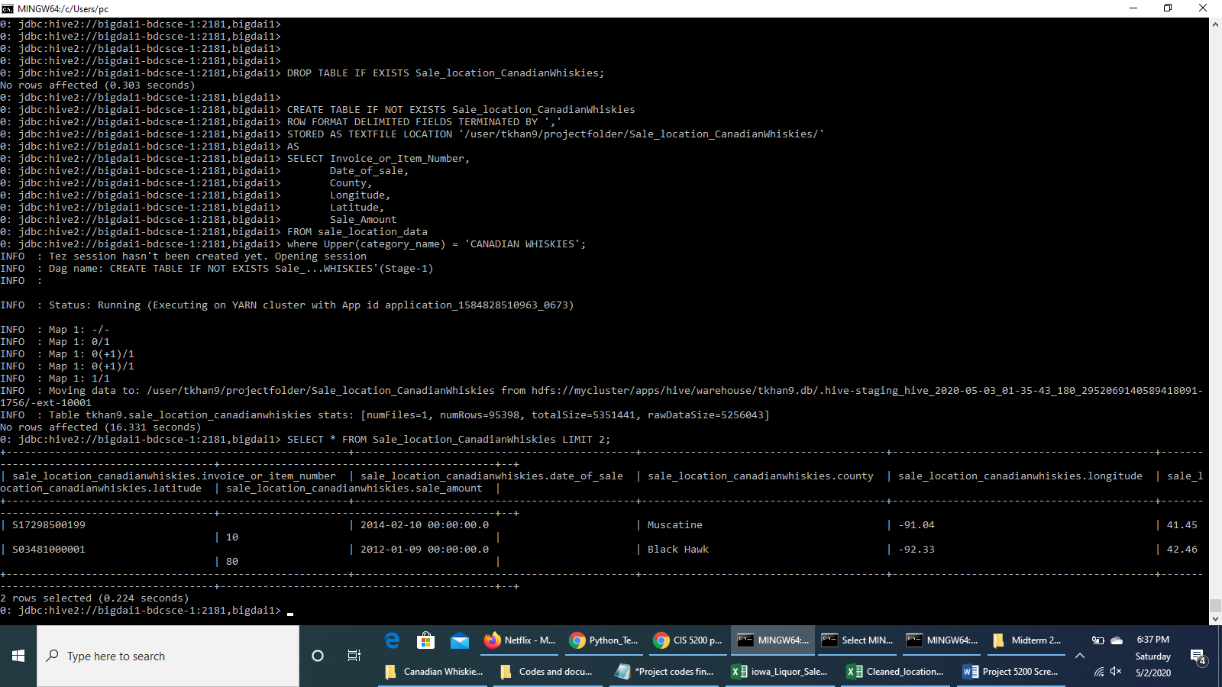

Press Ctrl+Z to exit Beeline.

Check HDFS path of the new output file 000000_0.

$ hdfs dfs -ls projectfolder/Sale_Location_CanadianWhiskies/

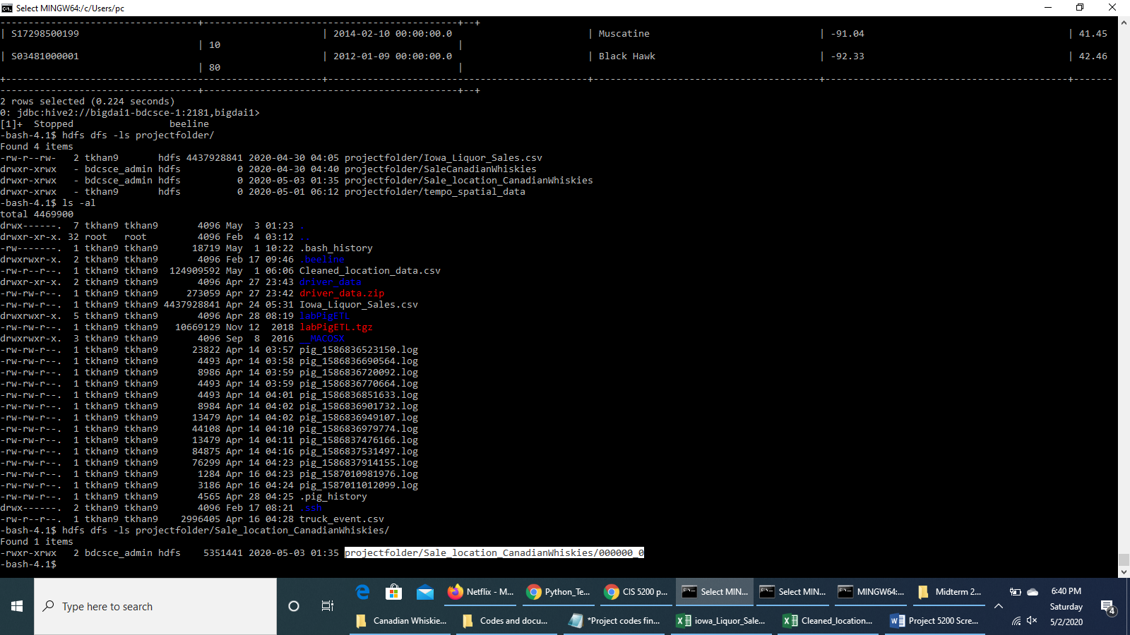

Download the output file to the local file systems:

$ hdfs dfs -get projectfolder/Sale_location_CanadianWhiskies/000000_0

Check that the file **000000_0** has been downloaded:

$ ls -al

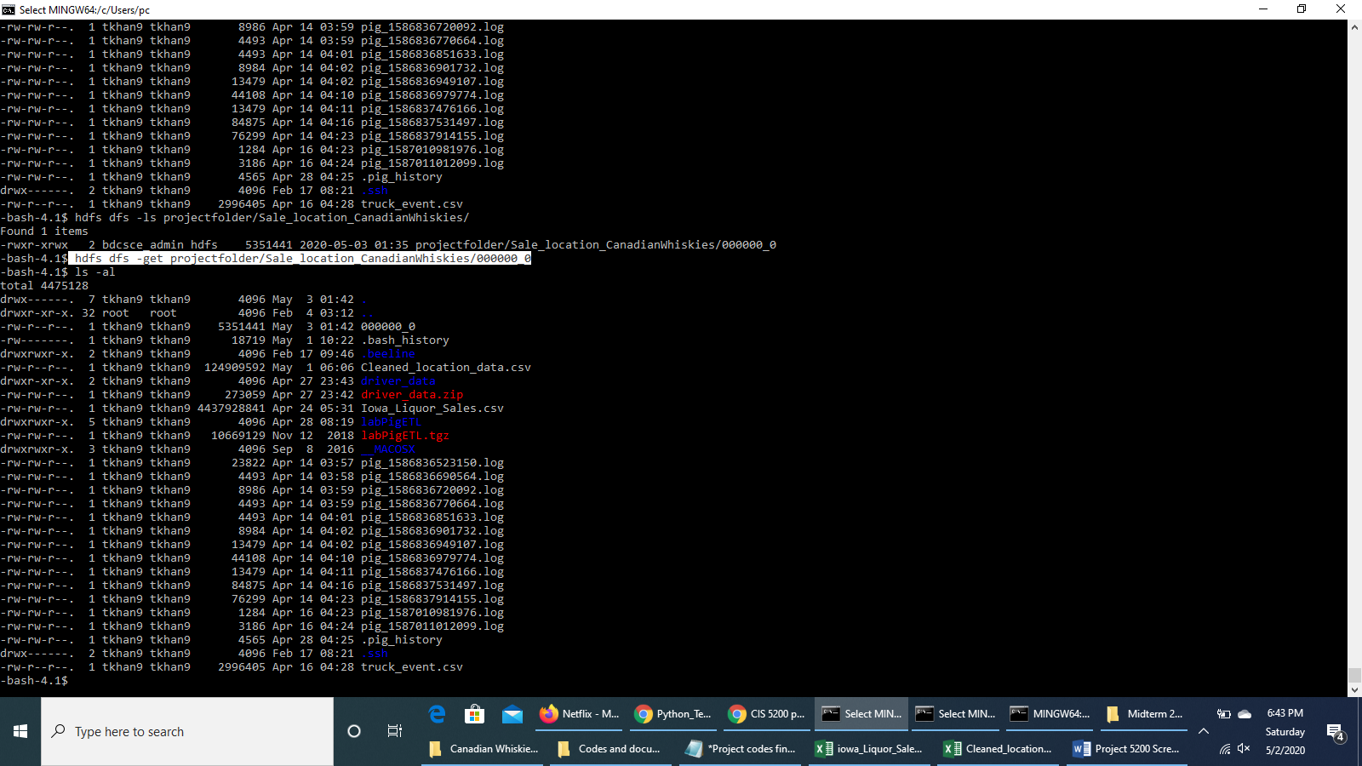

**Open another terminal with git bash in order to read/import the output file using our lab computer (or our PC/Laptop) - we have to download the file to our computer (or our PC/Laptop).**

scp tkhan9@129.150.71.75:/home/tkhan9/000000_0 000000_0.csv

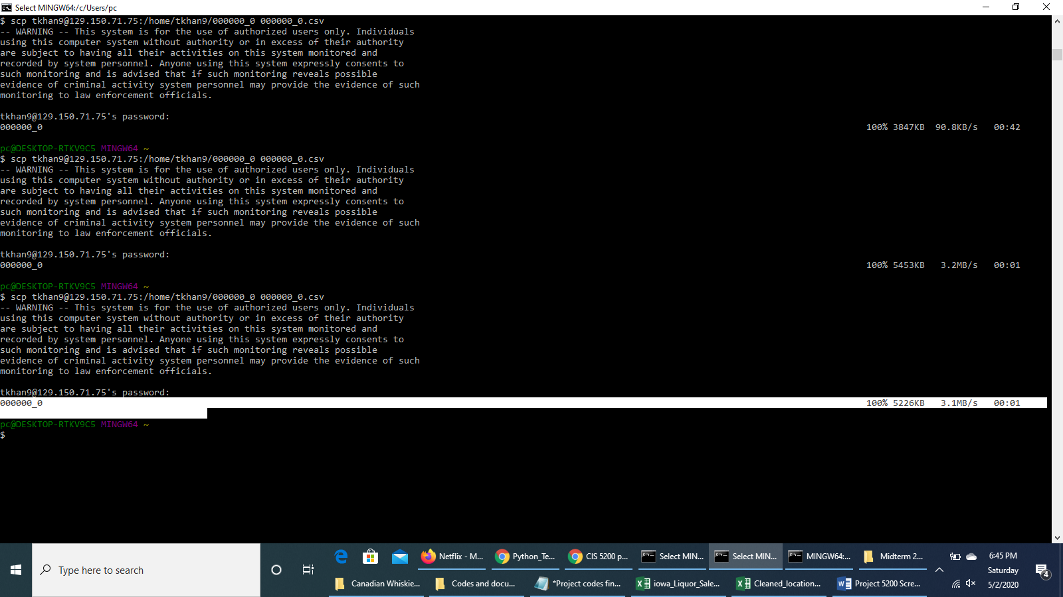

**Step 11 : Load data into Excel**

Go to the search box of your lab computer (or PC/laptop), type **000000_0.csv** and you will find the output file in your computer.

Open the csv output file, insert column headers as *Invoice_or_Item_Number*, *Date_of_sale*, *Longitude*, *Latitude* and *Sale_Amount*.

Then save the file in *.xlsx* format as Power Map only works in xlsx format.

Rename it to ***Canadian_Whiskies_Sale_results***.

**Step 12 : Visualization**

* **Using Excel 3D Map**

1. Select all the data in the Excel file and open 3D Map in Excel by **Insert > 3D Map**

2. When the 3D Map tab opens, select the fields as follows:-

**Location :** Latitude

**Height :**  Sale_Amount (Sum)

**Category :** County

**Time :** Date_of_sale (Year)

**Filter > Add filter :** Invoice_or_Item_Number (All)

Select ***Stacked Column*** as type of data visualization.

We will see the this 3D map result:

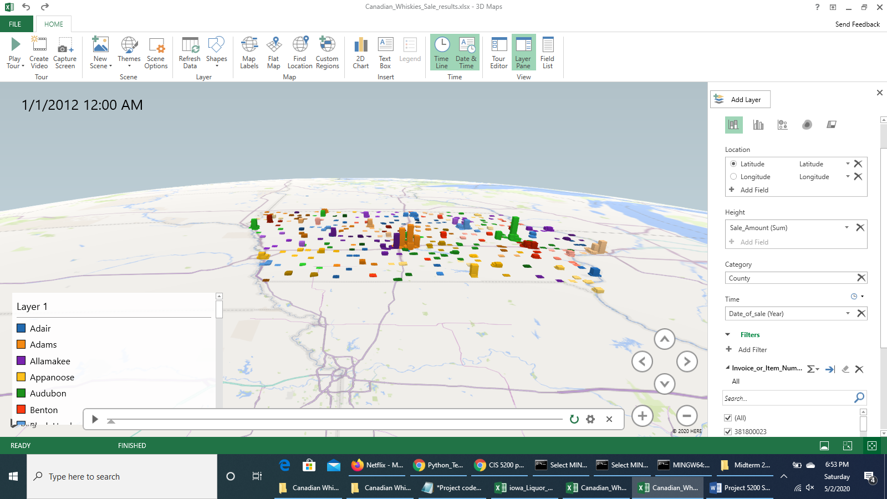

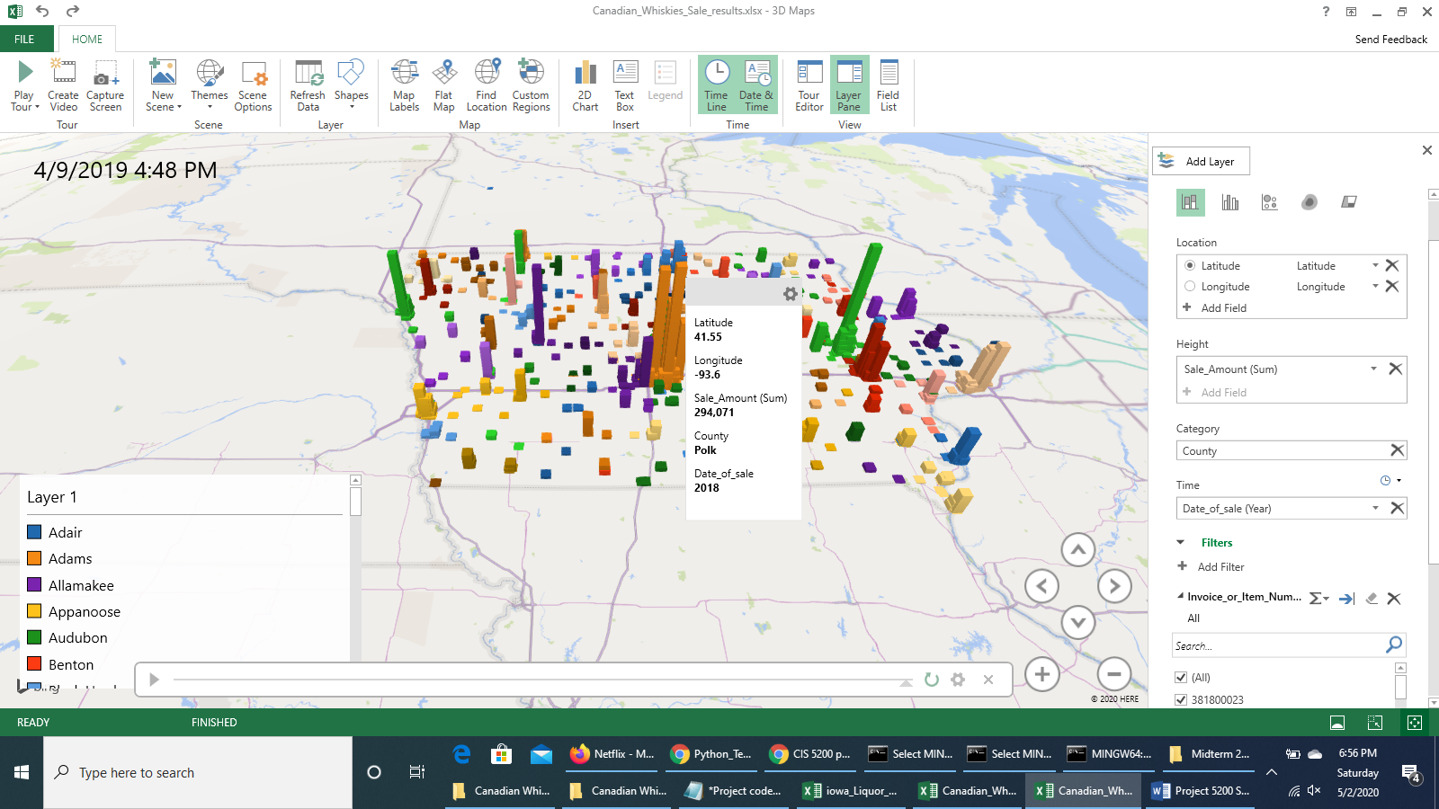

* **Using Power BI**

You need to sign in Power BI web site using your school account to imported the result data into Power BI to visually explore the data.

1. Open a web browser and go to and sign in with your school account at:

<https://app.powerbi.com>

2. Once you sign in, go to *Workspaces* and create a workspace giving any name. Once the workspace is created, in the *Create new* Content section, go to *Files*. Select *Local File* to upload the file “*Canadian_Whiskies_Sale_results.xlsx*”.

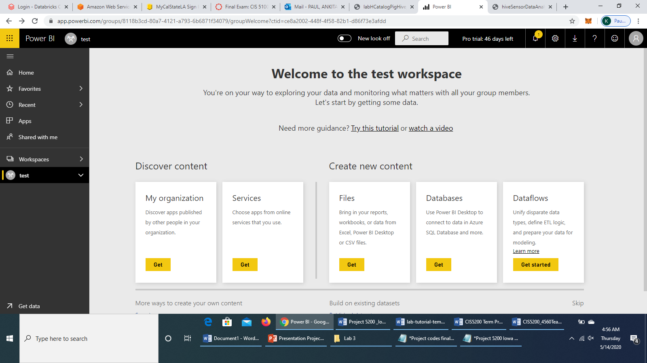

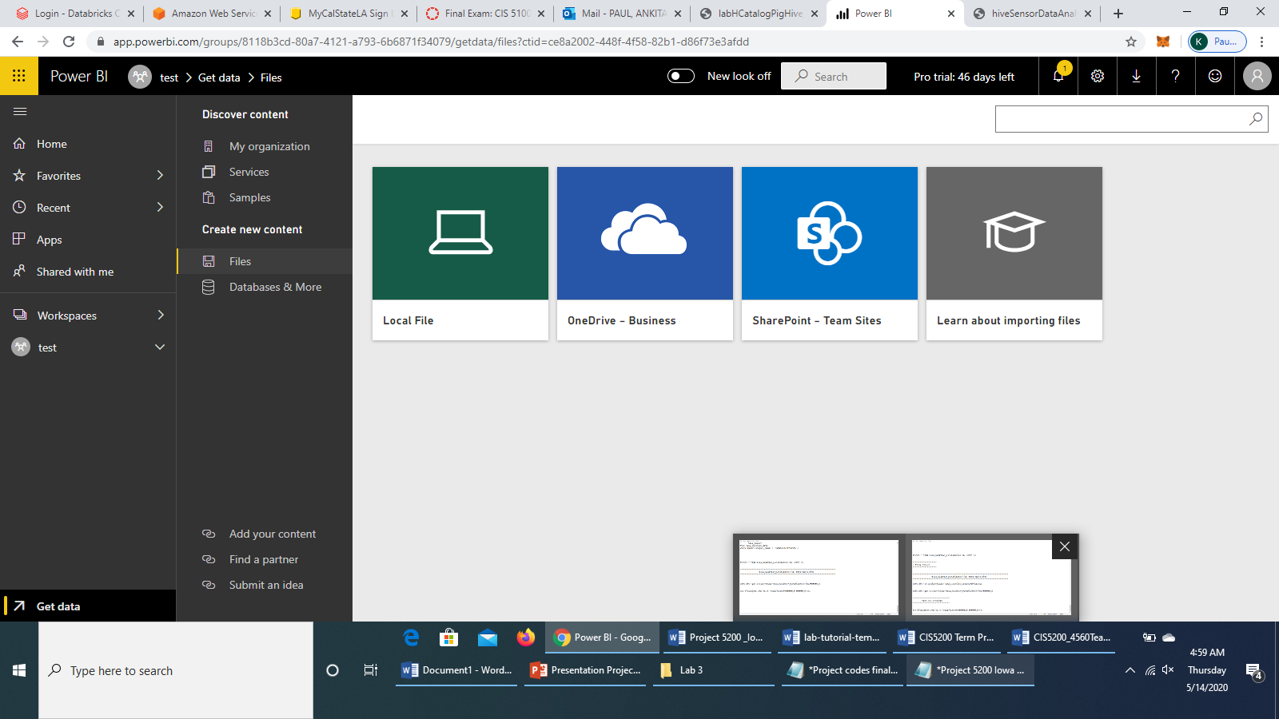

A window pops up like this. Go to your file location, select the file and click *Open*.

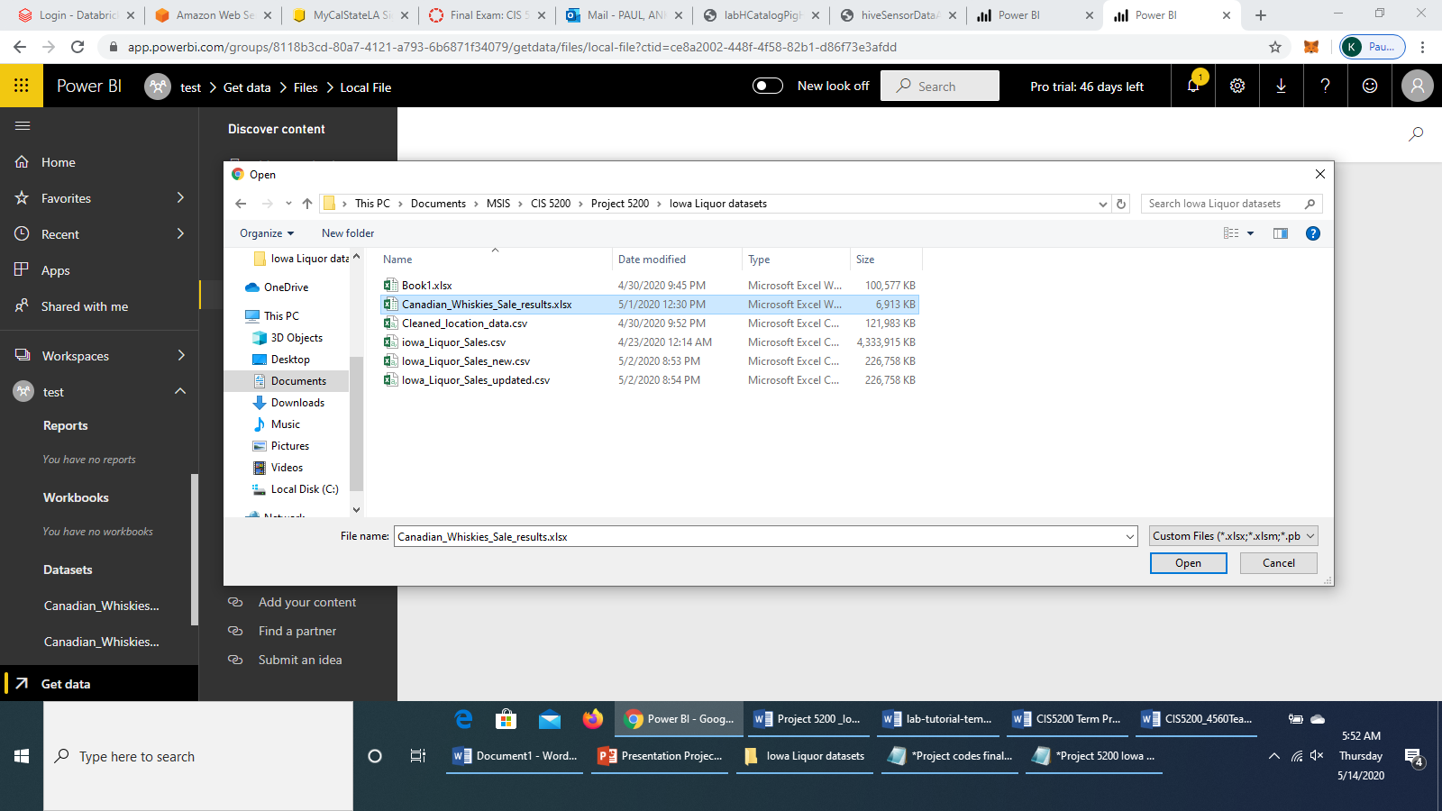

Select *Import*.

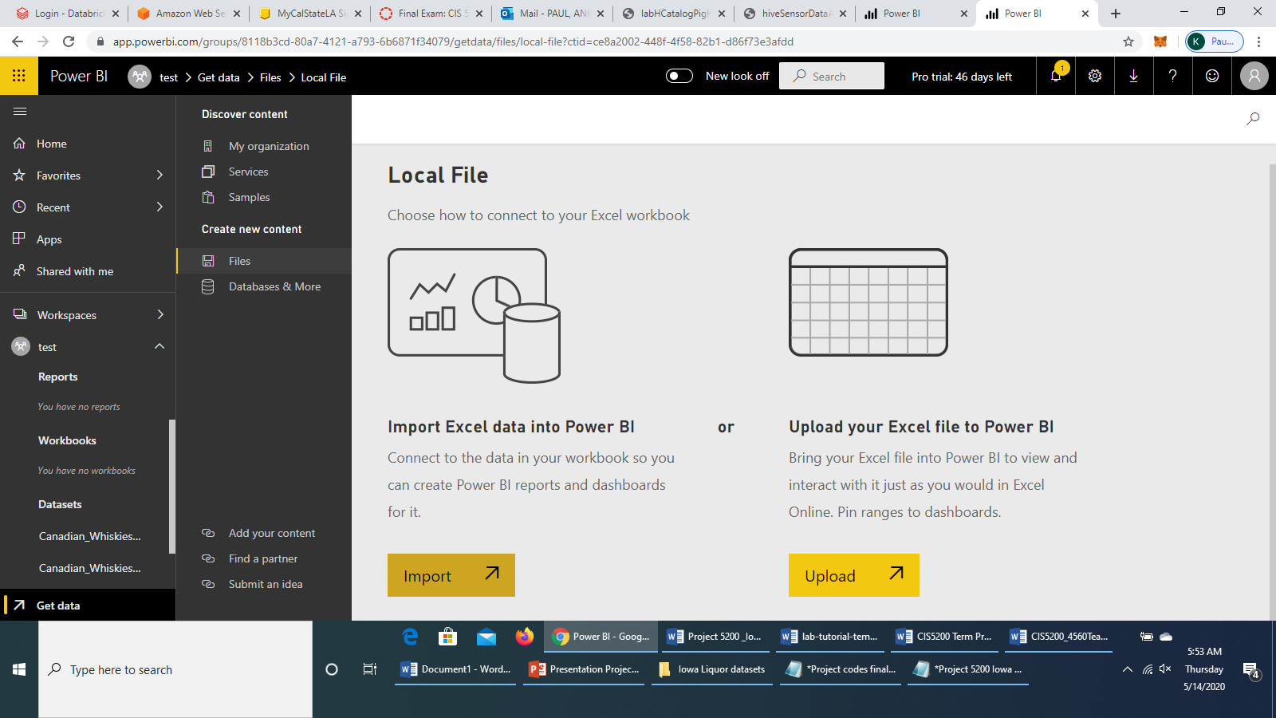

The file will be imported.

3. Once it has been imported, *Go to Dashboard*.

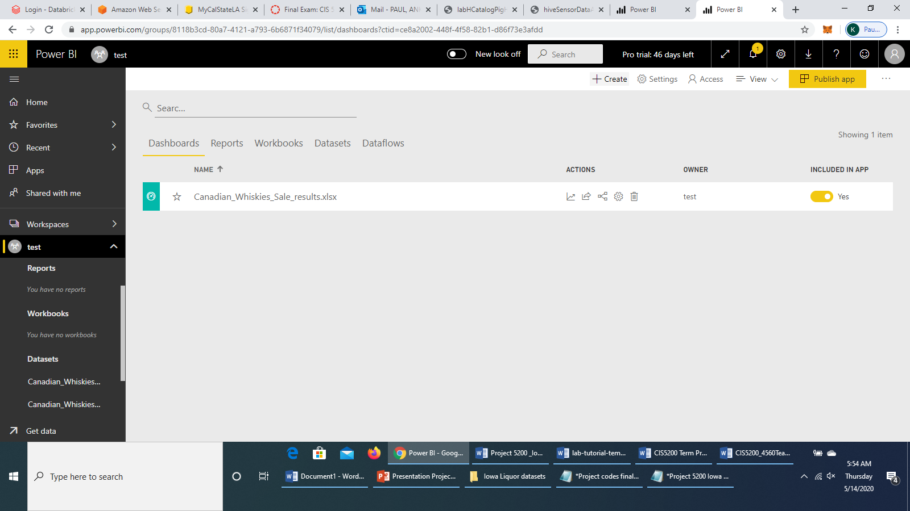

4. Click on *Canadian_Whiskies_Sale_results.xlsx* and you will see this page:

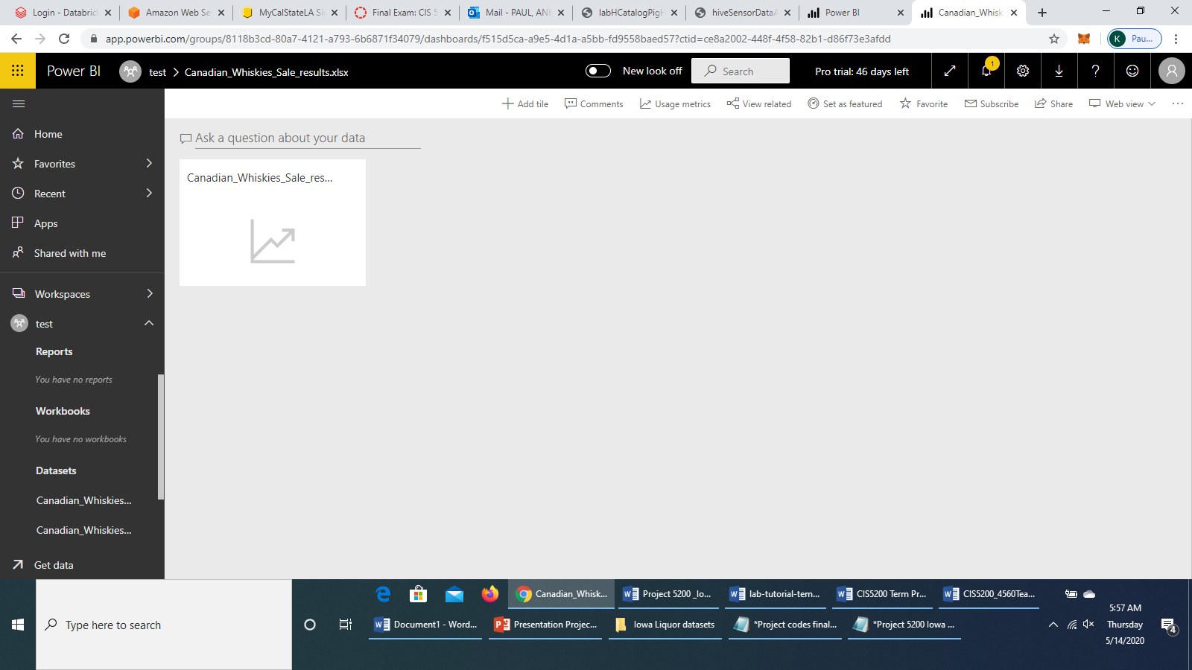

Select the *Canadian_Whiskies_Sale_results* dashboard.

5. When the new page opens, select table view in the visual chart icons:

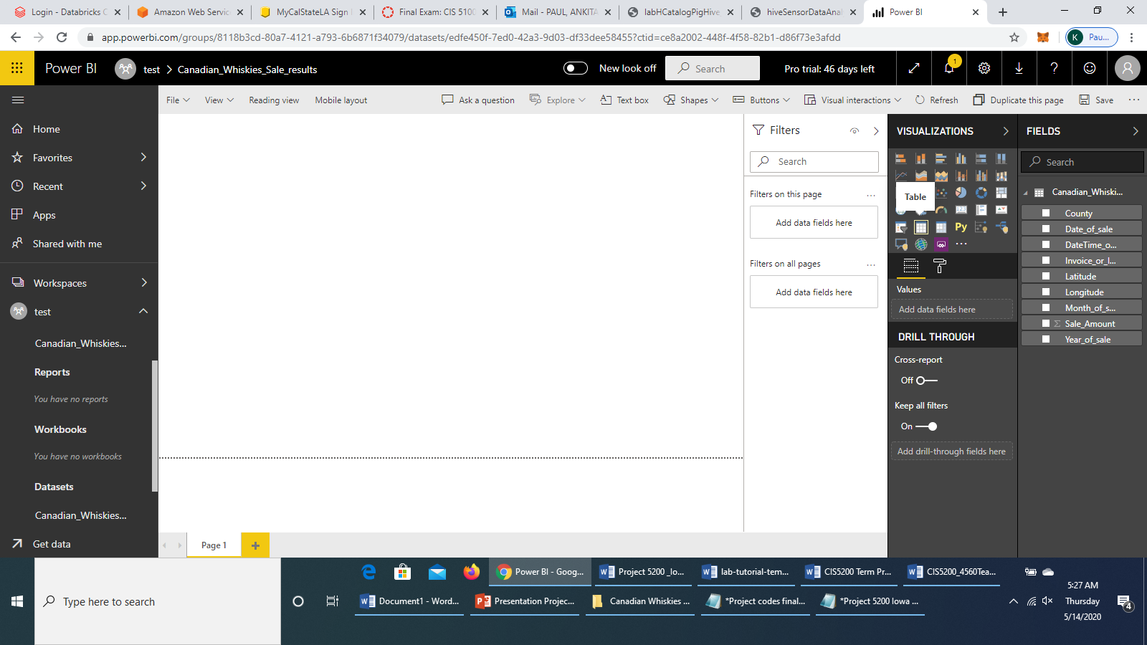

6. It will show you the following: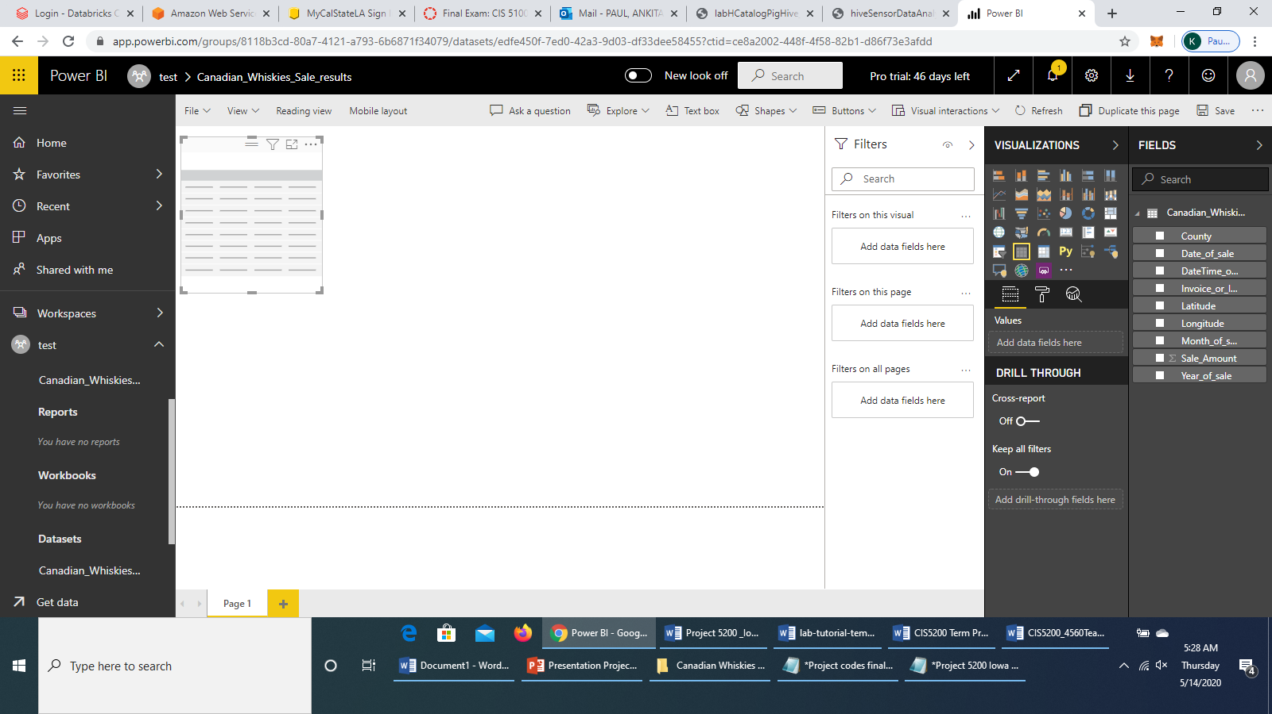

7. You can drag the edge of the table to make much bigger. And, you have to select values: **Date_of_Sale**, **Longitude**, **Latitude**, **County**, **Sale_Amount**.

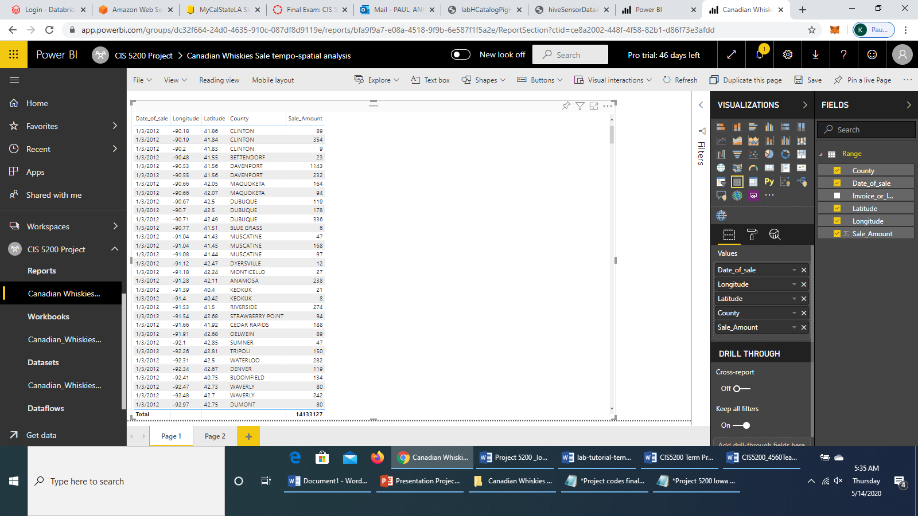

8. Click on “+” to create another page and then select Map chart in the visualization chart.

In the **Fields** section, select the values as:

**Legend :** Date_of_Sale

**Latitude :** Latitude (Set to “Don’t Summarize”)

**Longitude :** Longitude (Set to “Don’t Summarize”)

**Size :** Sale_Amount

It would look like this:

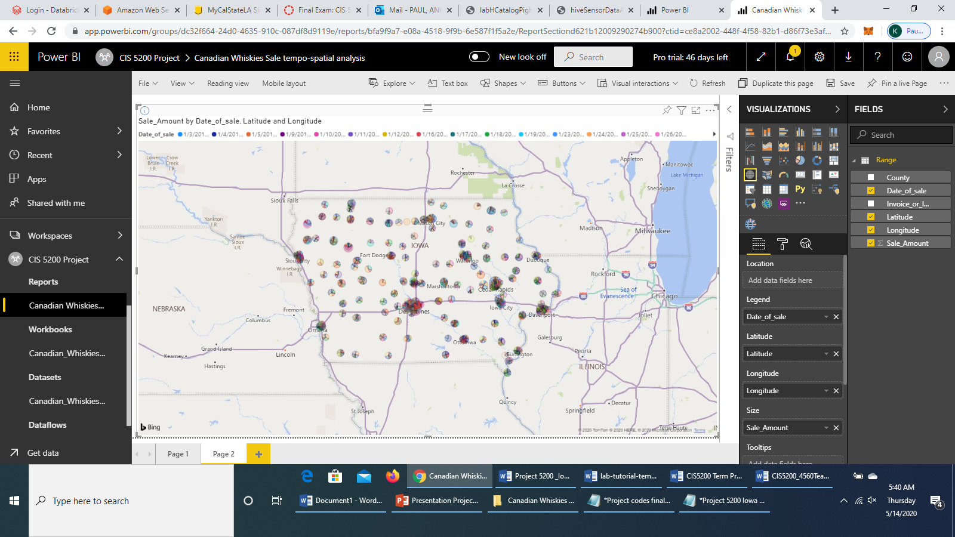

You will see that the sale amount is concentrated most at **Des Moines**, which is the highest ranked city in Iowa in terms of sale amount generated from liquor sales.

9. Go to *File > Save* to save your workspace. Name your report as **Canadian Whiskies Sale tempo-spatial analysis**.

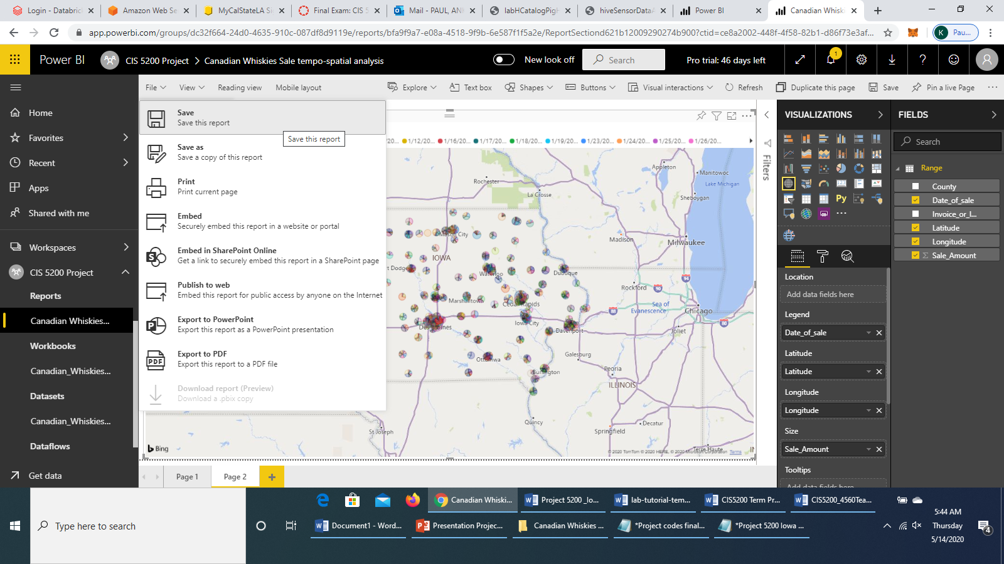

* **Using Tableau Data Visualization**

Tableau Software is used to transform data into actionable insights. In this tutorial, you will learn to create simple data visual graphs using Tableau. You will also learn how to import Excel files saved on your computer and load into Tableau. From our hive query tables, utilizing the final query information, simple Excel sheets were generated by putting the output records in Excel columns (outputs from each analysis part have been mentioned earlier along with the tutorial steps) . These Excel sheets were then used to create visualizations on Tableau.

Prerequisites:

* Tableau Software (you can download a 14-Day free trial and follow along).
* Excel 2013 and above.

Step 1. Open up Tableau workbook from your computer. You must have a Tableau account to continue.

Step 2: You must connect your data to your Tableau workbook. Connect to a file: Microsoft Excel. Click on Microsoft Excel.

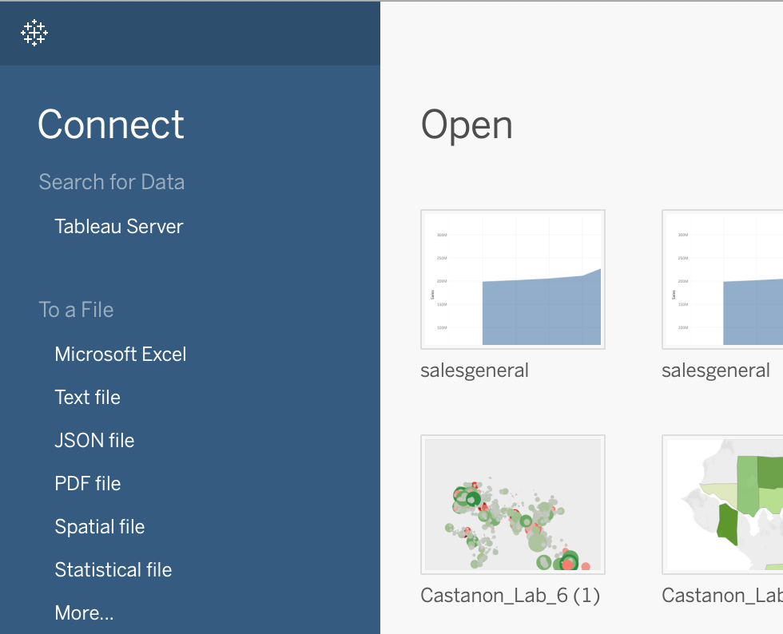

Step 3: (Assuming you have downloaded all the Tableau Data Excel sheets), upload the .xlsx file named salesovertheyears.xlsx by either double clicking on the file or clicking on the file and then clicking ‘open’.

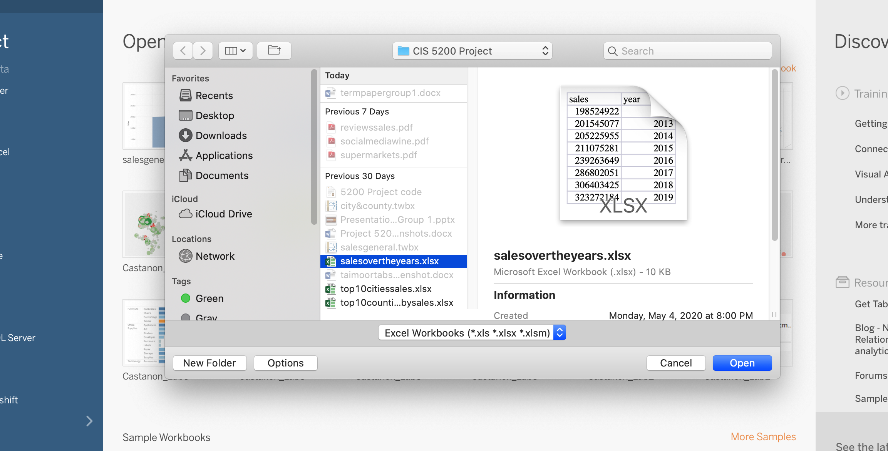

* Below is the .xlsx for **salesovertheyears.**

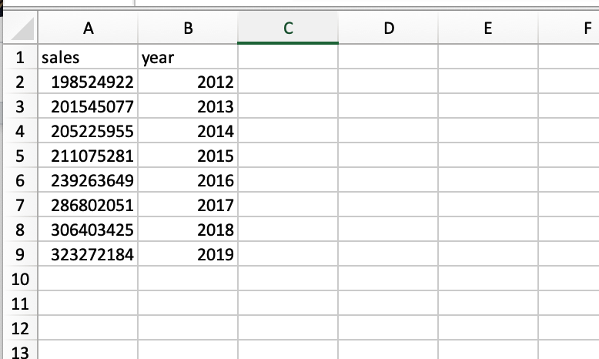

Step 4: Once you upload the excel data to the Tableau workbook you will see the following:

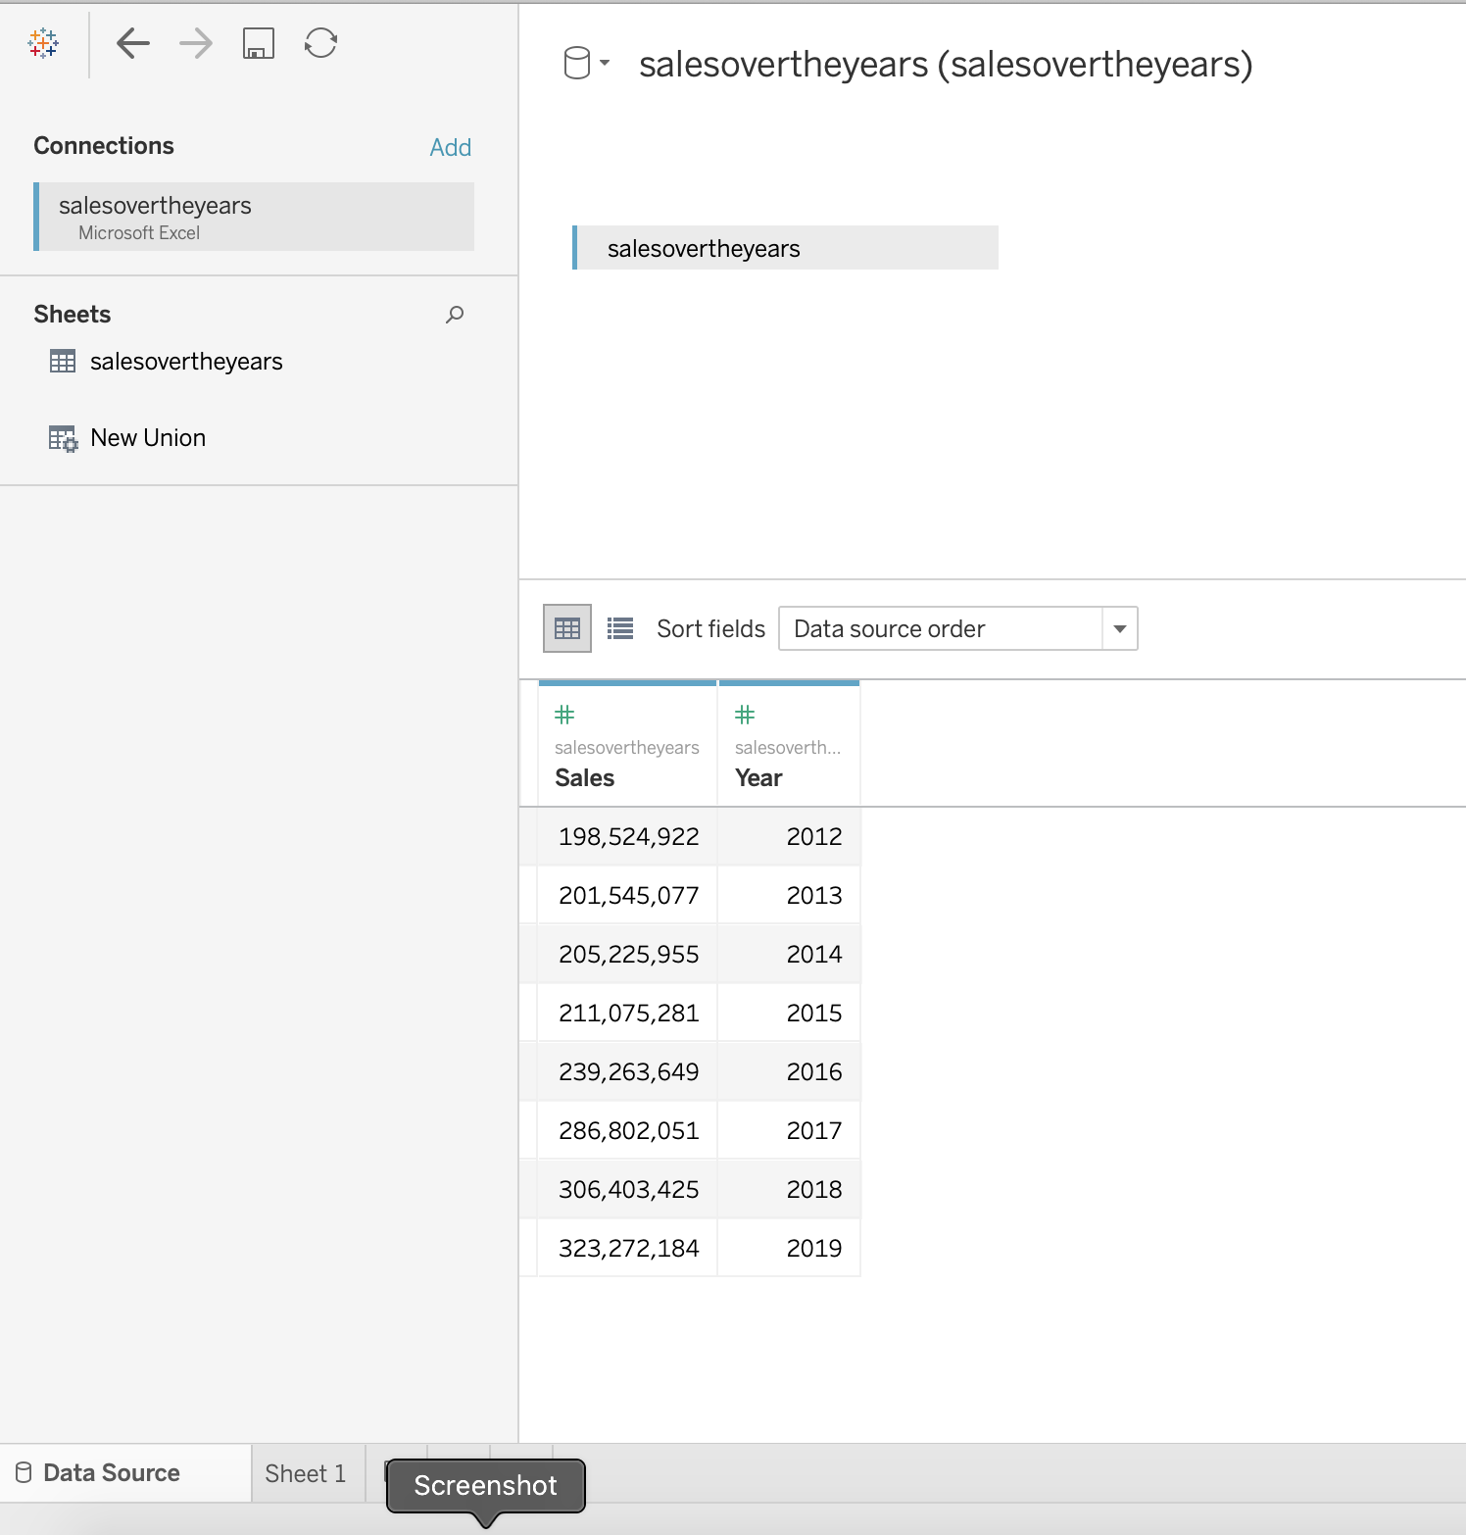

Then, at the bottom: click ‘Sheet 1’

Step 5: Drag your measures to the ‘Column’ & ‘Rows’. In this case, we are dragging the variable ‘Year’ to the columns line, and we are dragging SUM(Sales) to the ‘Rows’ line, as seen below.

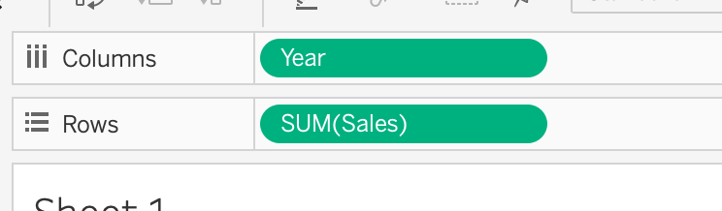

Below is what the dimensions look like. You can simply click, hold and drag the above mentioned dimensions and measures to their previously indicated locations.

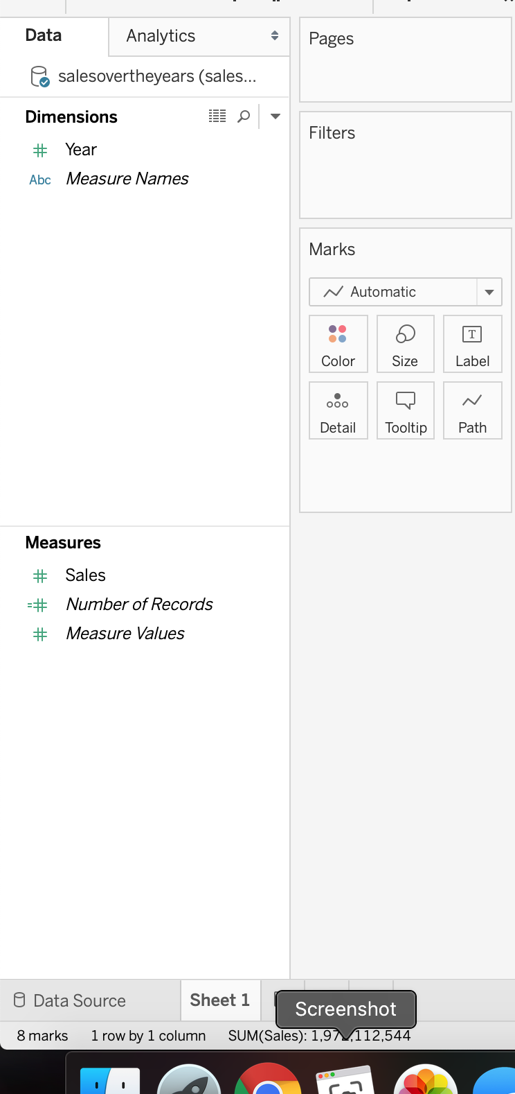

This is what your workbook should look like now: 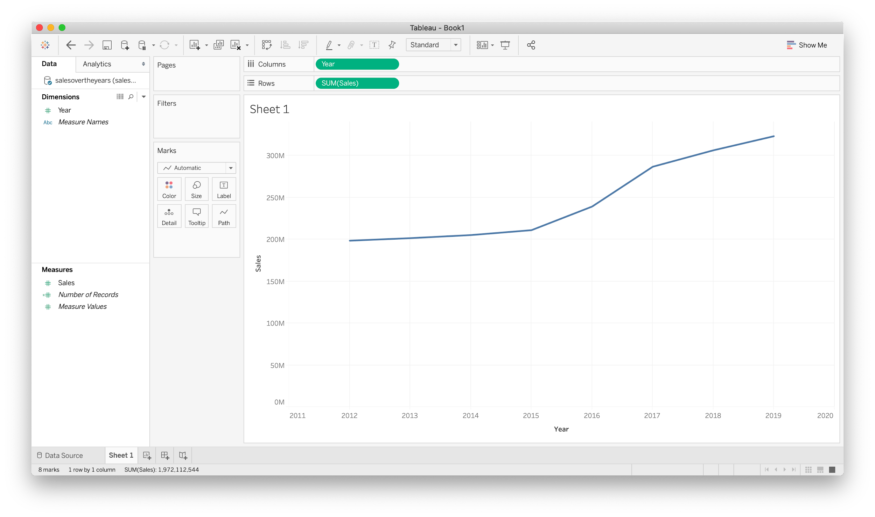Step 6: Edit your graph. Click on ‘Show Me’ in the top right corner. Then click on ‘Area Charts’ and your visual will look like this.

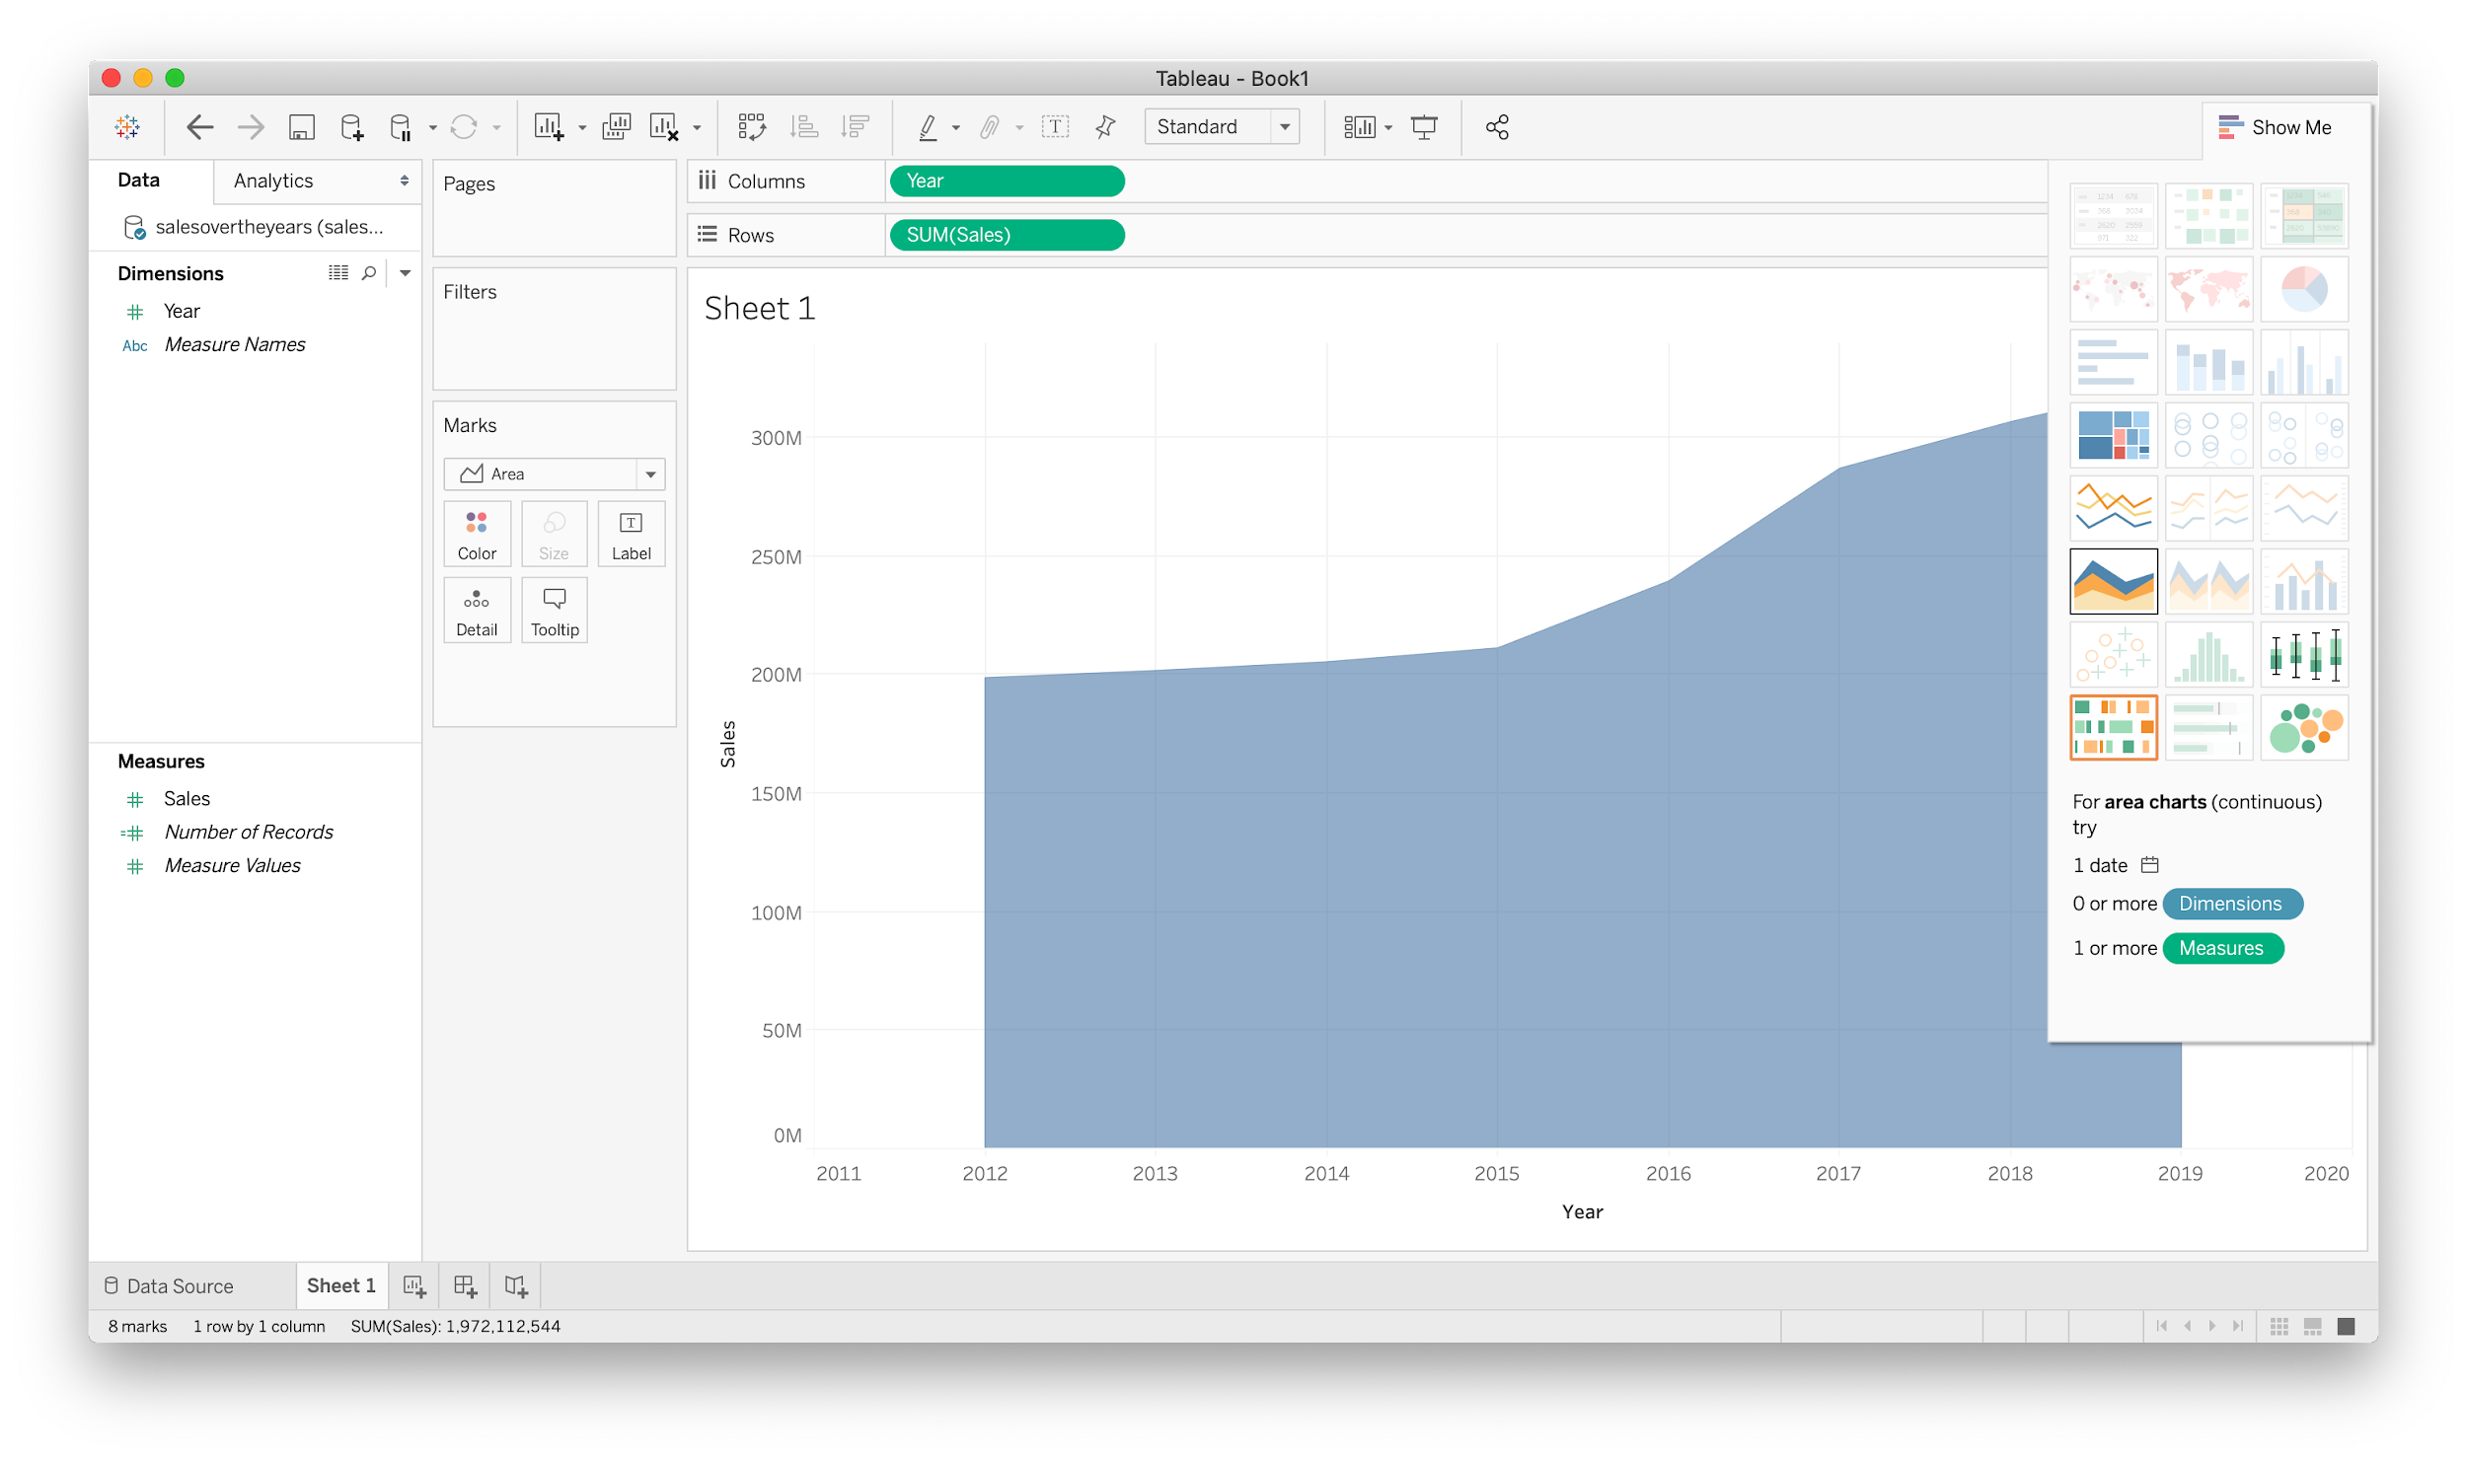

Step 7: Edit the title of the worksheet by double clicking where it says ‘Sheet 1’ right above the visual on the top left side. Title should be ‘Iowa Alcohol Sales from 2012-2019 (US Dollar)’. Then click ‘Apply’. 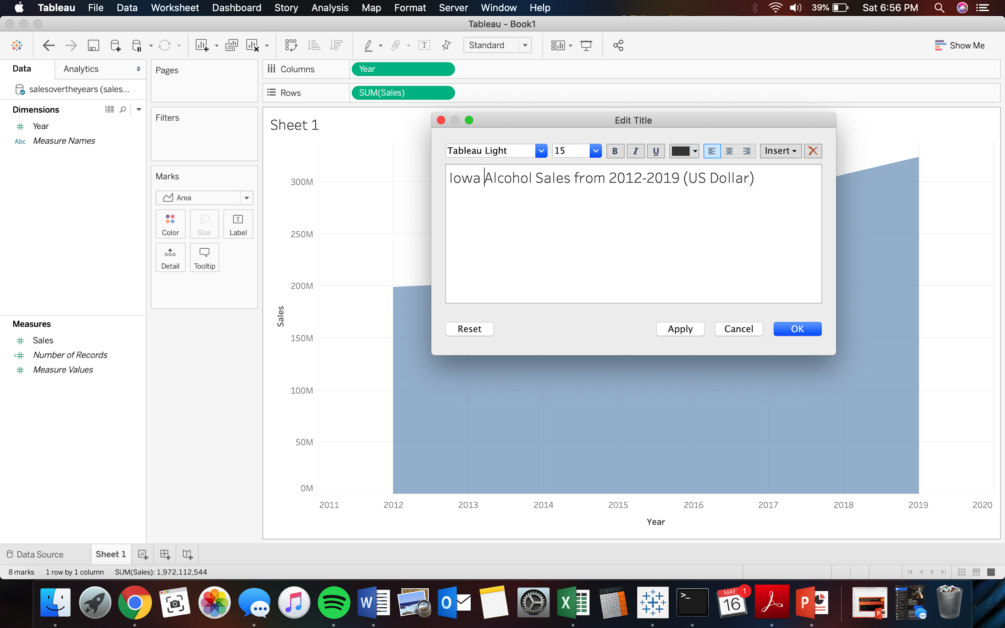

Step 8: Save as **.twbx** so it can be edited later if needed. You are now done with it.

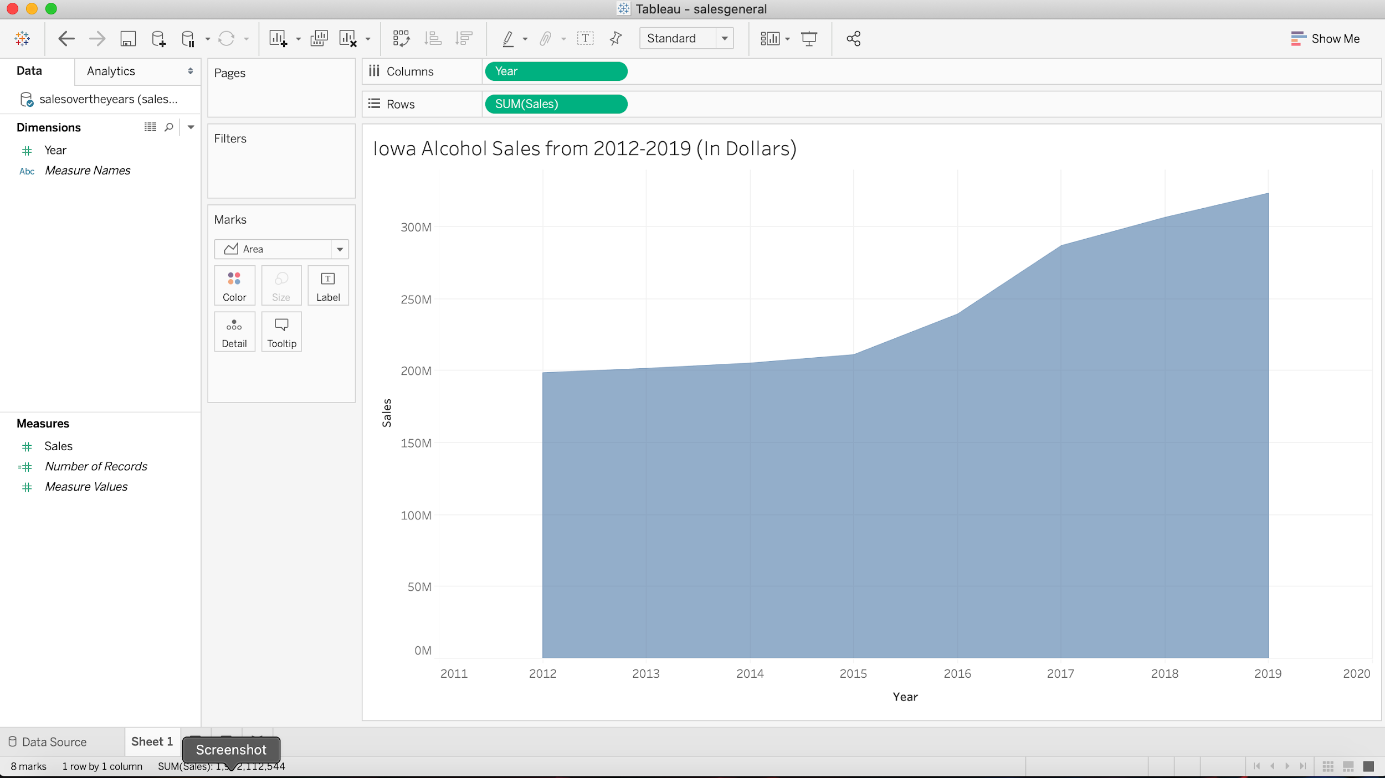

**For top10citiessales.xlsx & top10countiesbysales.xlsx**

Step 1: Open a new Tableau workbook. Follow steps 1-3 as outlined above, however you will choose one of the .xlsx files as indicated above.

Below is a screenshot of both .xlsx sheets.

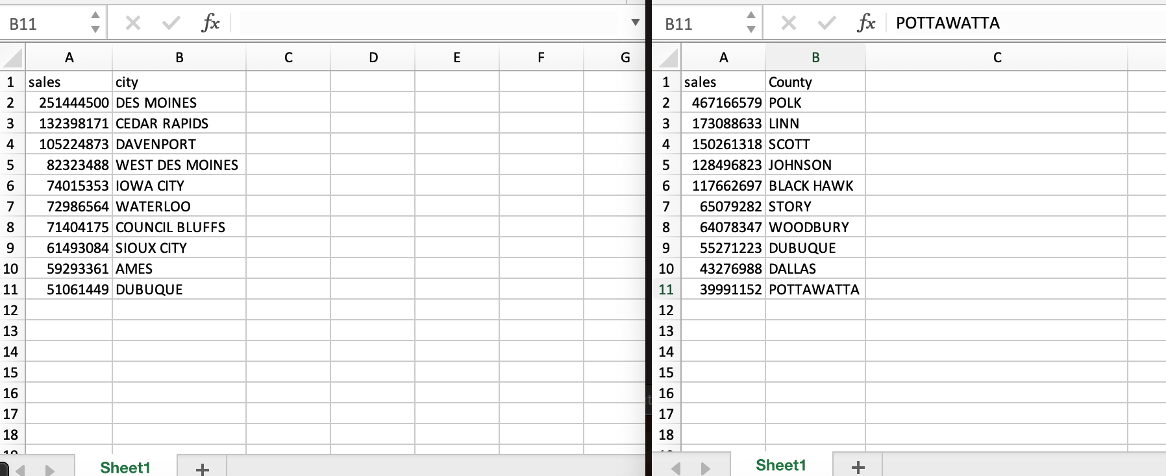

Step 2: Drag your measures & dimensions to their corresponding spaces for rows and columns as shown below:

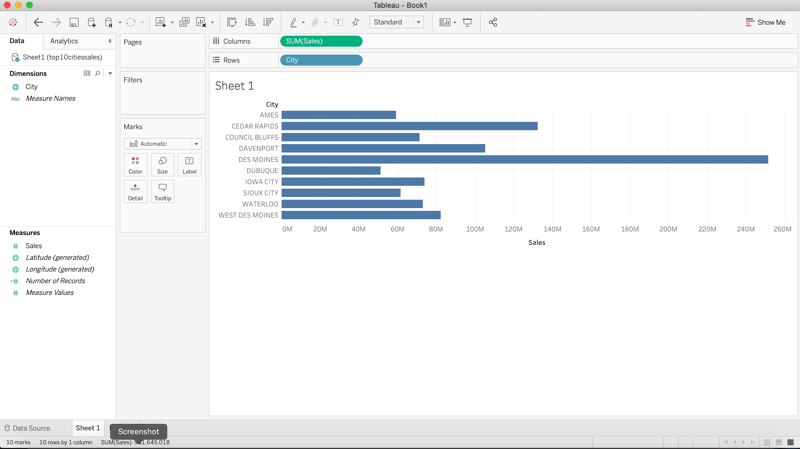

Step 3: Organize data into descending order by clicking on the top column where it shows the graph lines with an arrow going downward, and your visual should look like this:

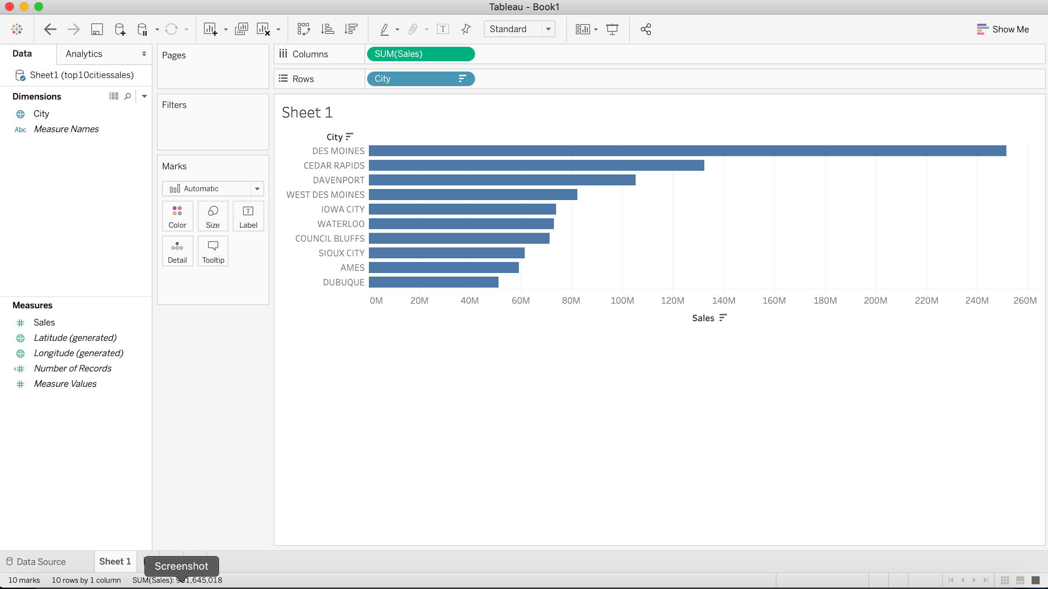

Step 4: Adjust the height of the graph by clicking as shown below with ‘*Fit Height*’.

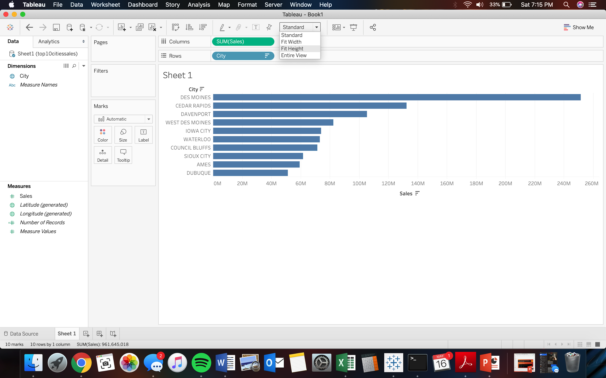

A) Your visual should now look like this: 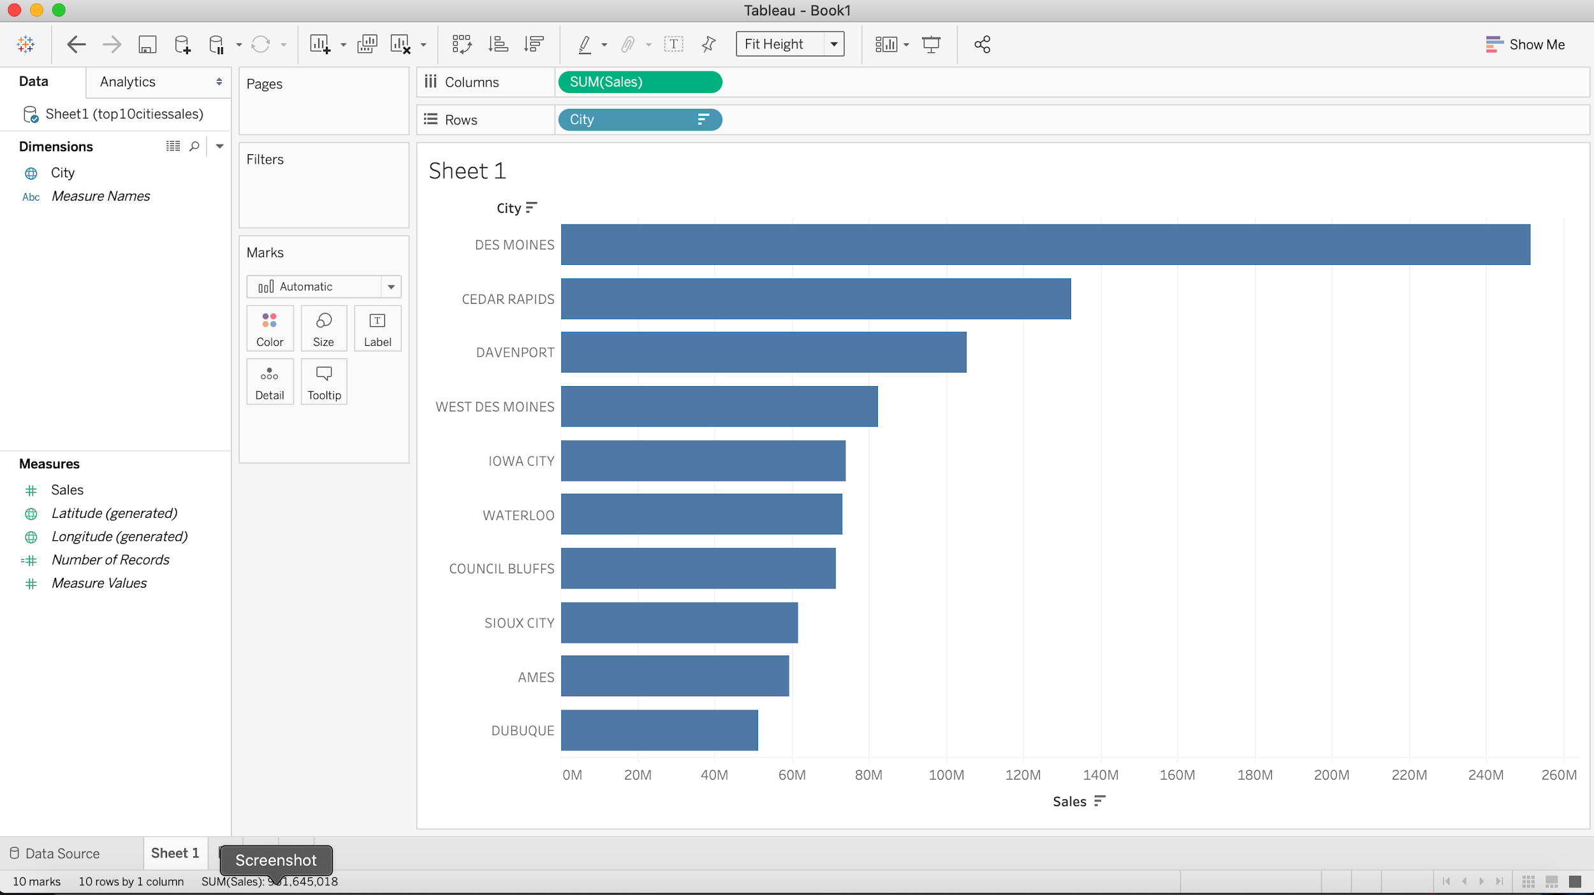

B) You can change the colors to your liking: 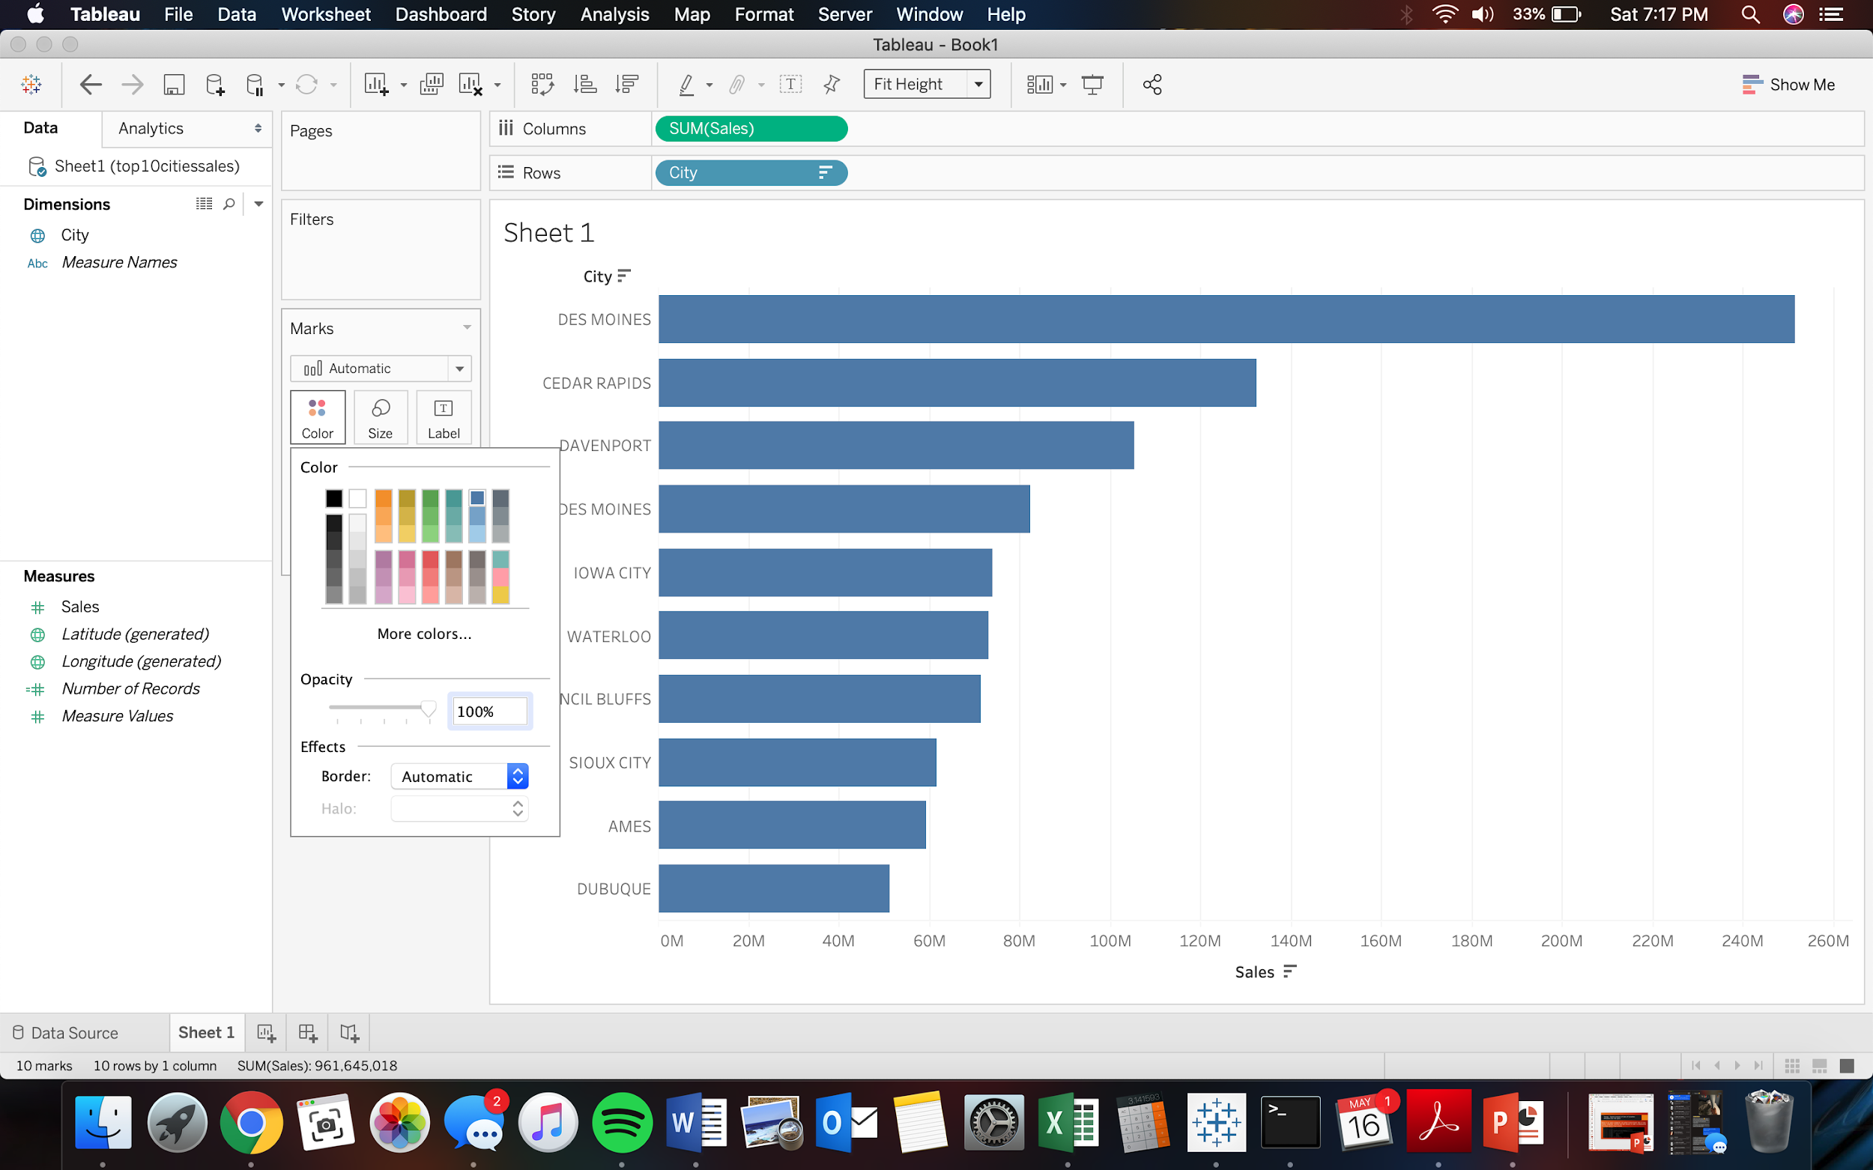

C) Be sure to add a title as shown previously, the steps are the same. 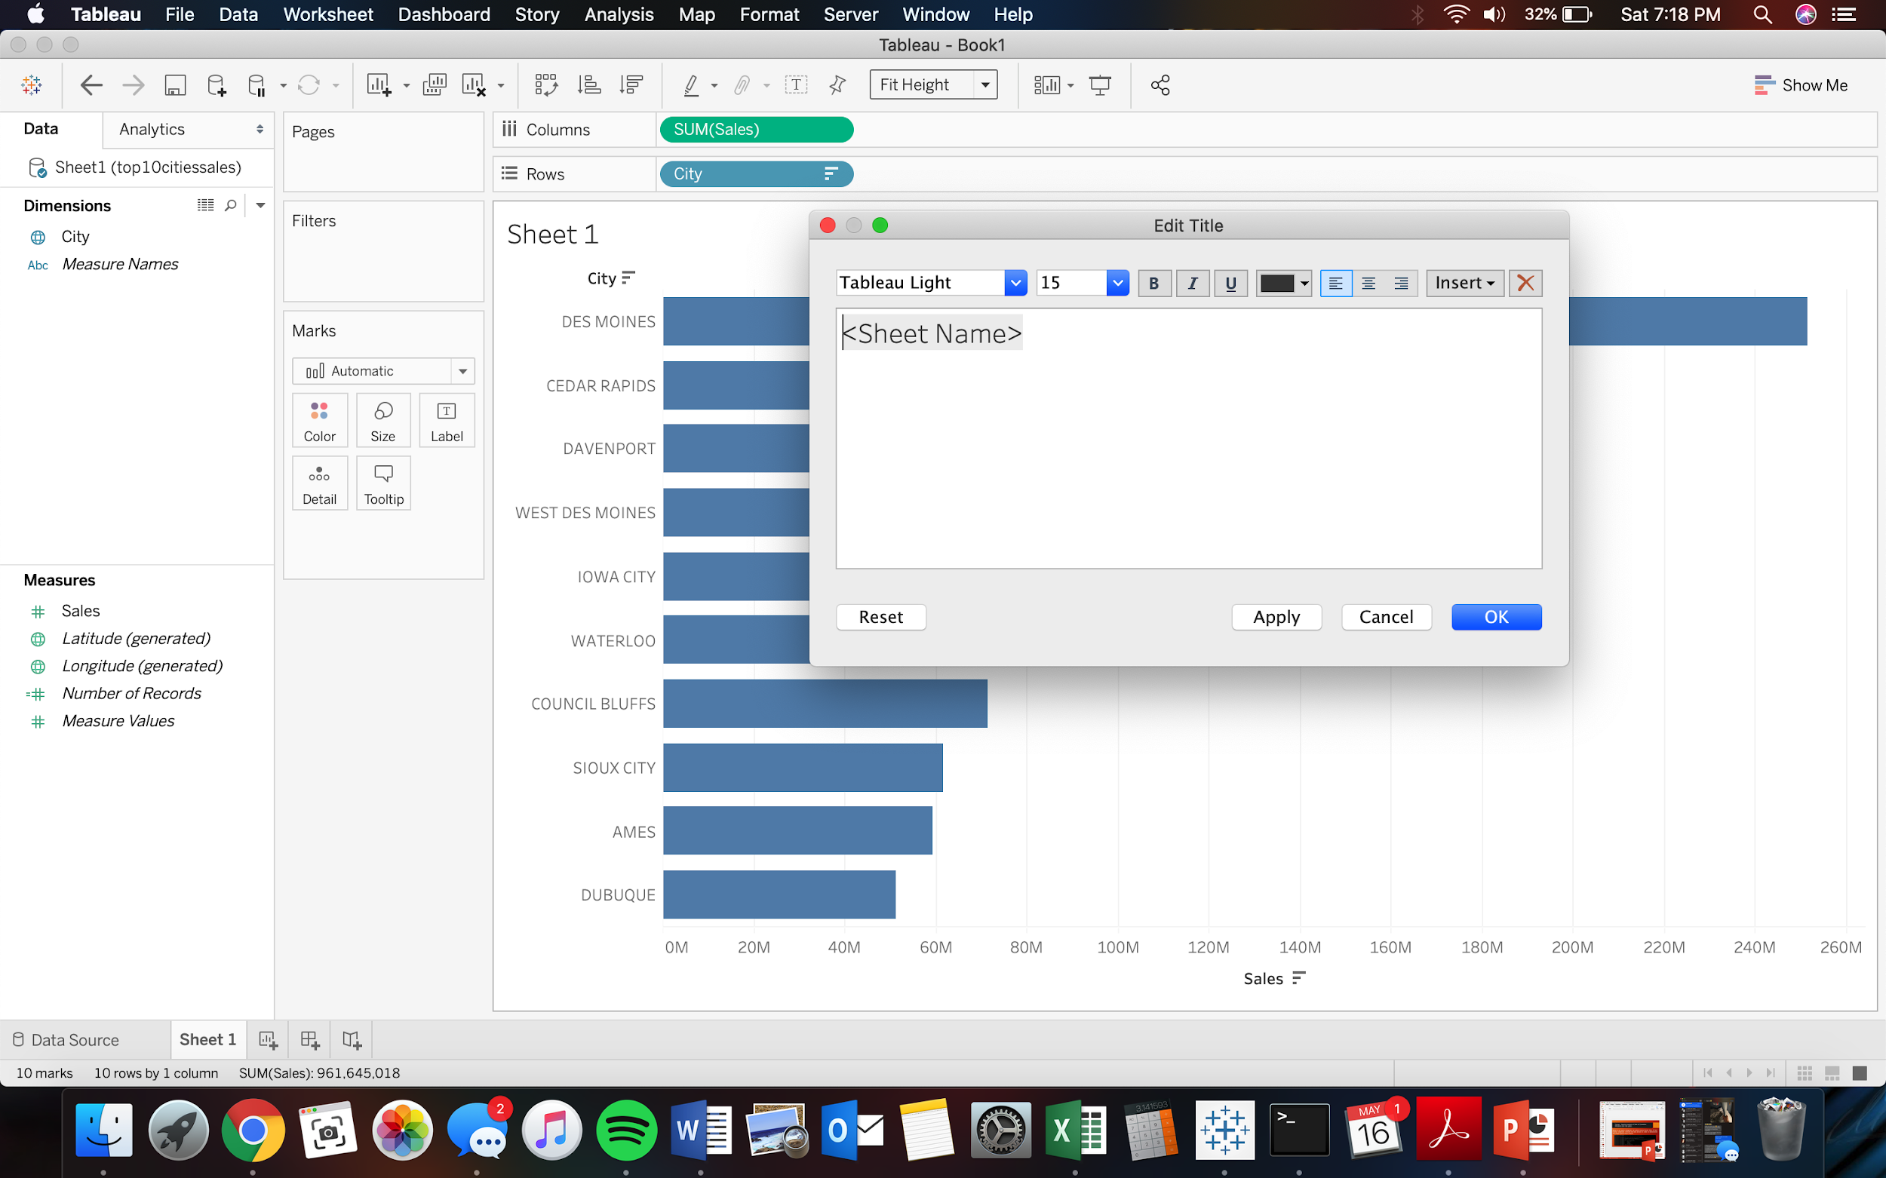

Step 5: Save as a **.twbx** file format. Please follow the same procedures for both data sets listed above (Top 5 categories of Liquors sold in terms of Volume in Liters)

Step 6: Title each accordingly.

***Top 5 categories of Liquors sold in terms of Volume in Liters:***

1. After opening Tableau we are shown a screen like this, where we click on ‘Microsoft Excel’ and then locate and select our desired dataset file:

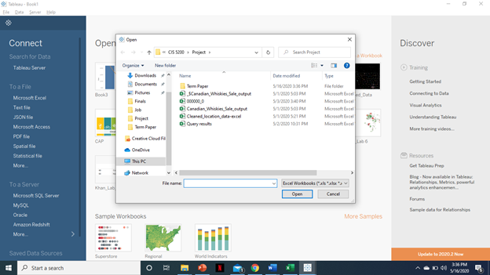

2. We will open the file and then a new sheet will open while linking while showing data column and attributes at the left:

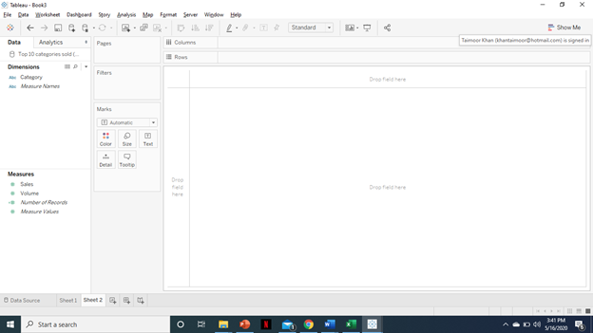

3. Then we will move ‘Category’ into Columns section at the top and move ‘Sales’ and ‘Volume’ in Rows.

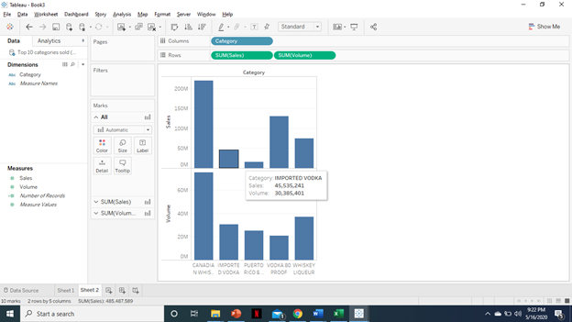

4. Then we will click on the bar on bottom ‘Sum(Volume)’ and change it to ‘Line’ from Automatic

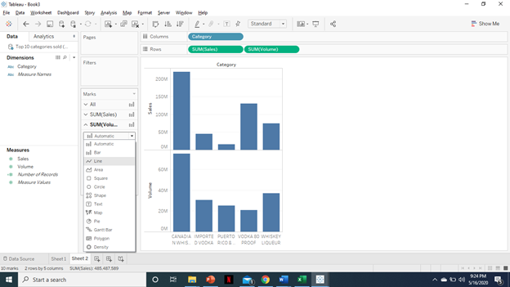

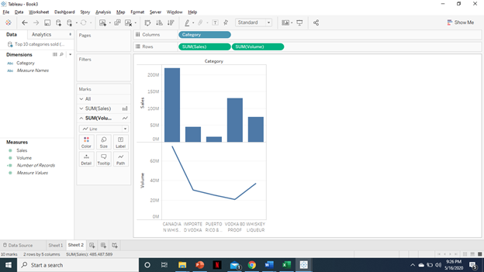

5. Then we will left click on left side on bottom bar chart and select ‘*Dual Axis*’.

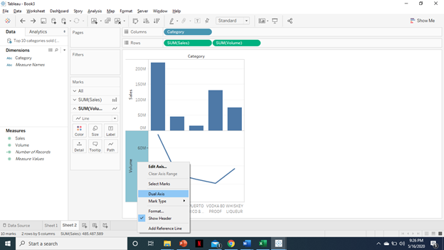

6. Next, we will click on marks ‘Sum(Sales)’ and change it from Automatic to ‘*Bar*’.

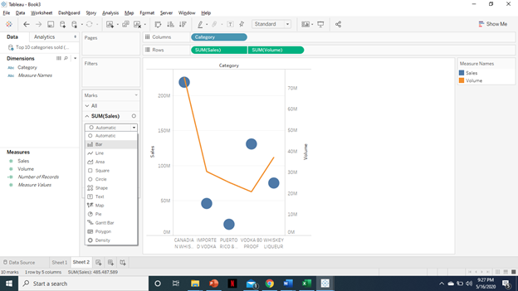

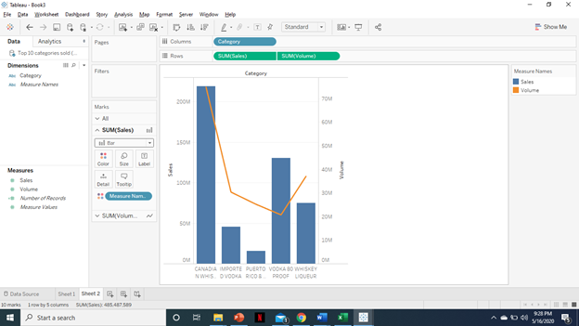

7. Click on ‘Columns’ at top and click *Sort*. Then you can sort manually or in descending order.

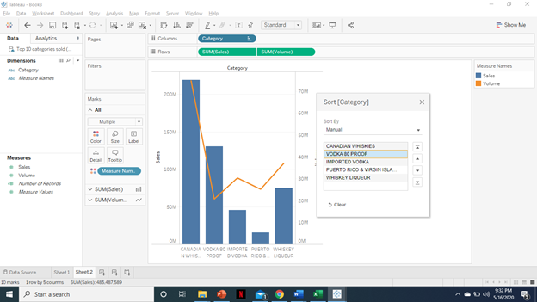

Final Visual:

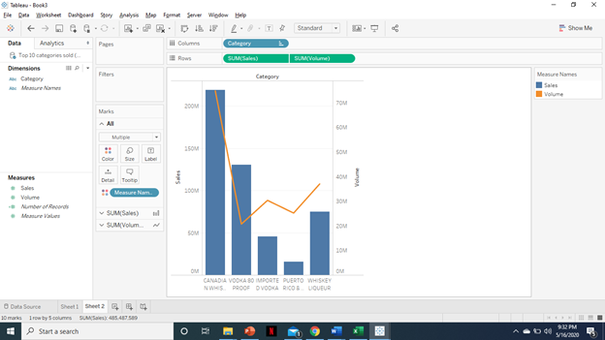

***Sales trend of Canadian Whiskies in 2019:***

1. First step is the same as for the previous visual. But here we will use a different dataset that will show different ‘Dimensions’ and ‘Measures’.

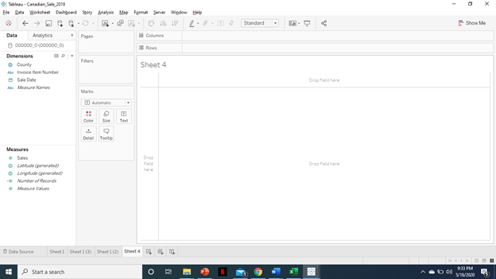

2. We will drag ‘Sum(sales)’ into Rows and ‘Year(Sale Date)’ into Columns.

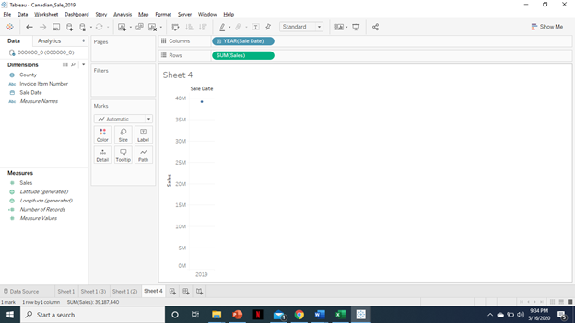

3. Now we will click on the + sign at YEAR and expand it till we can see the month.

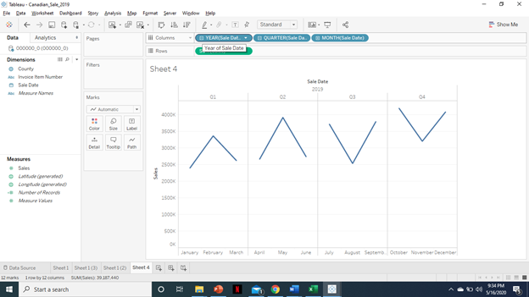

4. Now we will remove Year and Quarter from Columns. Left click on them and select *Remove*.

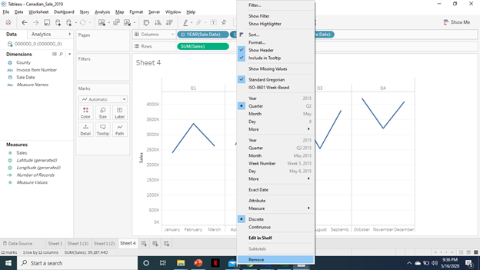

Final Visual:

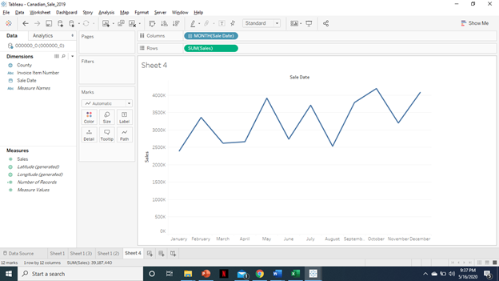

***Temporal Analysis of Sale of Canadian Whiskies across the counties of year 2019:***

1. First step here again will be the same as the previous visual tutorial, the dataset we used for this visual is the same as the previous one.

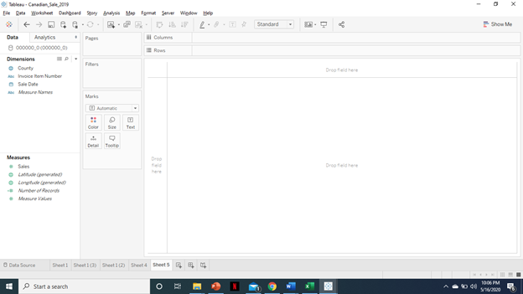

2. Now move ‘Sales Date(Year)’ into Columns and ‘Sum(Sales)’ into Rows and then expand Sales option till you get the month and then remove others, similar to previous steps done in previous visuals

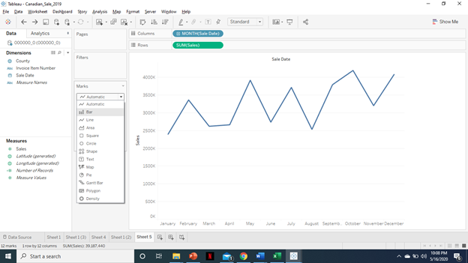

3. Now change the marks tab to ‘*Bar*’.

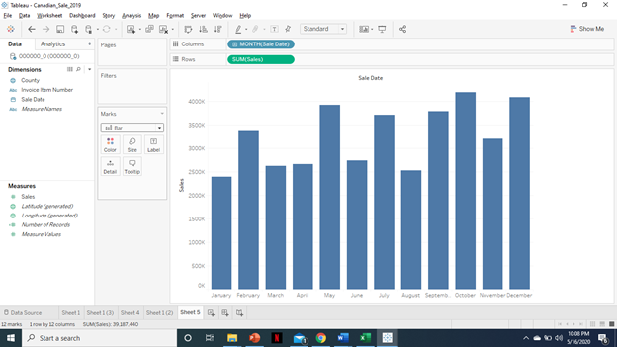

4. Now move ‘County’ from Dimensions to ‘Color’ in marks.

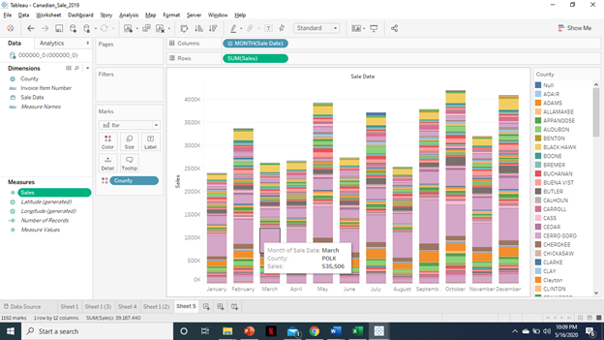

5. Also move ‘Sum(Sales)’ to Size in marks and ‘Sales Date’ to Label, then keep expanding till you get to ‘Date’.

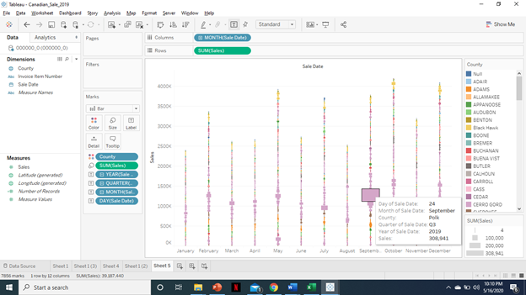

6. Now we will remove other ‘Sales(Date)’ by left clicking and selecting *Remove*.

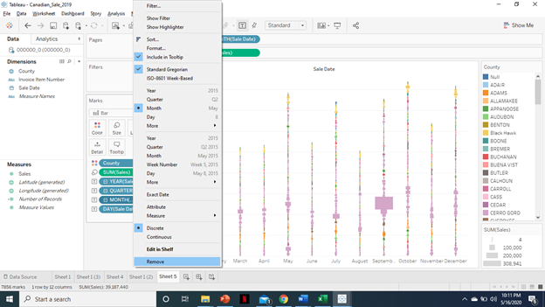

7. Now move ‘Measure Names’ from Dimensions to ‘Filters’ and then left click and select ‘*Show Filter*’.

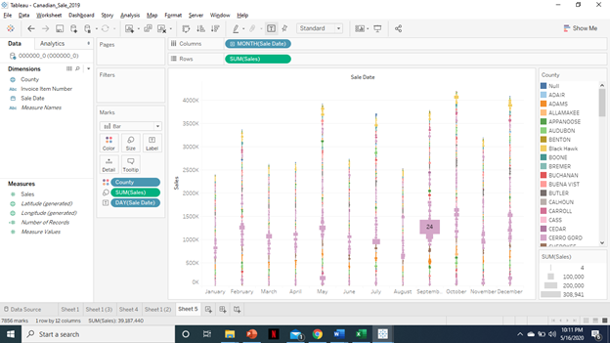

Final Visual:

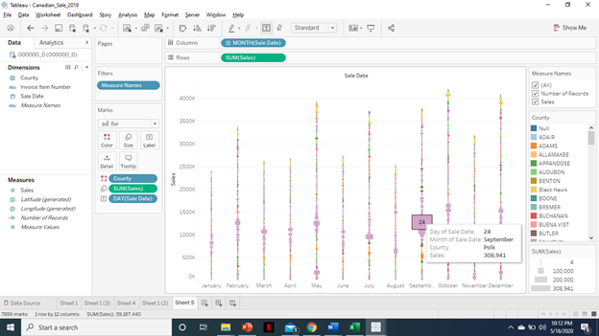

**References:**

1. **URL of Data Source**

* **Original Datasource link:**

https://data.iowa.gov/Sales-Distribution/Iowa-Liquor-Sales/m3tr-qhgy

* **Amazon S3 link to iowa_Liquor_Sales.csv :**

<https://projectcis5200.s3-us-west-1.amazonaws.com/iowa_Liquor_Sales.csv>

* **Amazon S3 link to Cleaned_location_data.csv**

<https://projectcis5200.s3-us-west-1.amazonaws.com/Cleaned_location_data.csv>

**2.** **URL of our Github:** https://github.com/apaul11/CIS5200

3. **URL of References**:

* lab2HiveLogAnalysis_Oracle.pdf
* hiveSensorDataAnalysisLab_oracle.pdf
* hiveTwitterSentimentAnalysisLab_oracle.pdf
* Hive, Chapter 11, *Cloudera*
* Youtube Link to 3D Map Video capture: https://youtu.be/nYV3qjIAUEI
* Link of visualization on Power BI: https://app.powerbi.com/groups/dc32f664-24d0-4635-910c-087df8d9119e/reports/bfa9f9a7-e08a-4518-9f9b-6e587f1f5a2e?ctid=ce8a2002-448f-4f58-82b1-d86f73e3afdd